

**Marine SABRES Deliverable 3.1**

**Simple Social-Ecological Systems Guidance**

Amanda Gregory, Jonathon Atkins, Gemma Smith, and Michael Elliott



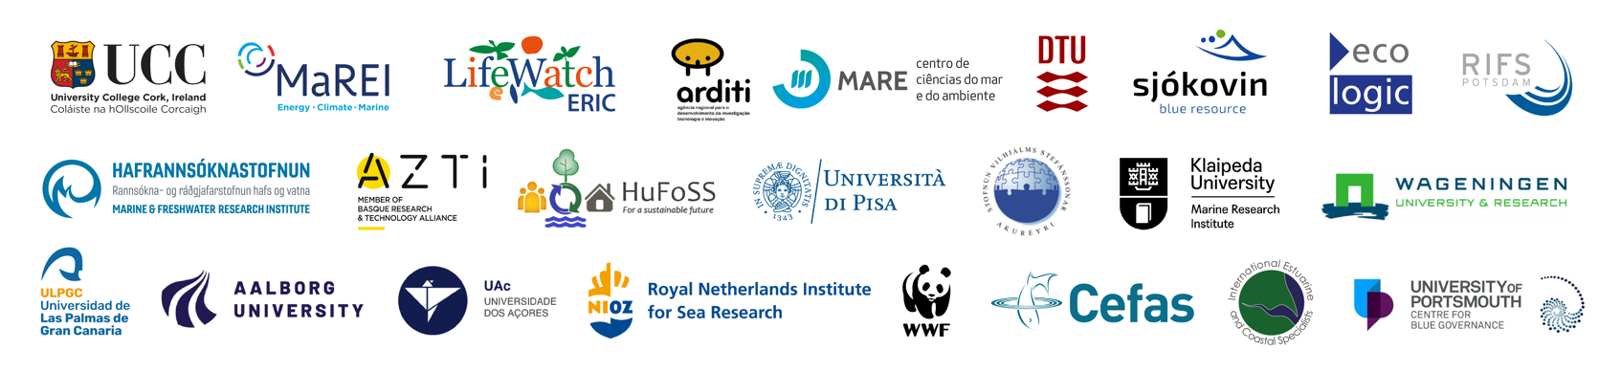

## DOCUMENT INFORMATION

|  |  |  |  |  |  |
| --- | --- | --- | --- | --- | --- |
| Version | Date | Description | | | |
|  |  | **Responsible** | **Authors** | **Reviewed by** | **Approved by** |
| 1 | 28/04/23 | Jonathan Atkins and Amanda Gregory | Jonathan Atkins and Amanda Gregory | Gemma Smith |  |
| 2 | 12/06/23 | Gemma Smith | Gemma Smith | Mike Elliott |  |
|  |  |  |  |  |  |
|  |  |  |  |  |  |

|  |  |
| --- | --- |
| Authors (alphabetical) | |
| Name | **Organisation** |
| Amanda Gregory | IECS |
| Gemma Smith | IECS |
| Jonathan Atkins | IECS |
| Michael Elliott | IECS |

|  |  |
| --- | --- |
| Acknowledgements/contributions (alphabetical) | |
| Name | Organisation |
|  |  |
|  |  |

## DISCLAIMER

The content of the publication herein is the sole responsibility of the authors and does not necessarily represent the views of the European Commission or its services.

While the information contained in the documents is believed to be accurate, the authors(s) or any other participant in the MarineSABRES consortium make no warranty of any kind with regard to this material including, but not limited to the implied warranties of merchantability and fitness for a particular purpose.

Neither the MarineSABRES Consortium nor any of its members, their officers, employees or agents shall be responsible or liable in negligence or otherwise howsoever in respect of any inaccuracy or omission herein.

Without derogating from the generality of the foregoing neither the MarineSABRES Consortium nor any of its members, their officers, employees or agents shall be liable for any direct or indirect or consequential loss or damage caused by or arising from any information advice or inaccuracy or omission herein.

Contents

DOCUMENT INFORMATION 1

DISCLAIMER 1

List Of Figures 4

Introduction - Integrated Systems Analysis (ISA) 6

Part I: The Process and Information Management System 7

Using the DAPSI(W)R(M) Framework for Issue Structuring 7

Process and Information Management System (PIMS) 9

Demonstration Area Management 10

Initiation Phase 10

Implementation phase 11

Closure phase 12

Resource management 13

Stakeholder identification and engagement 13

Communication and impact management 15

Data provenance and management 17

Evaluation 18

Process evaluation 18

Outcome evaluation 19

Governance Sub-System 19

Part II: The Integrated Systems Analysis 21

Overview – Integrated Systems Analysis Part by Part 22

Part A: 22

Part B 23

Part C 23

Visually Representing Complexity - DAPSI(W)R(M) and Causal Loop Diagramming 24

Causal Loop Diagrams 24

Elements 26

Aggregation and disaggregation 26

Connections 28

System Scales and Levels 28

Causal Loop Diagramming in Kumu 30

Dynamic Complexity and Behaviour Over Time (BOT) 30

Summary of the recommended DAPSI(W)R(M)/CLD modelling process: 31

Part III: The Simple SES Analysis 33

Preliminary Exercise 0: Unfolding Complexity and Impacts on Welfare 33

Exercise 1: Specifying Goods and Benefits Related to the Impact on Welfare 35

Exercise 2: Specifying State Changes (Marine Ecosystem Processes and Functioning and Ecosystem Services) that affect Impacts on Welfare (Goods and Benefits) 36

Exercise 2 (a) For Ecosystem services: 36

Exercise 2(b) for Marine Ecosystem Processes and Functioning: 38

Exercise 3: Specifying Pressures on State Changes (Marine Ecosystem Processes and Functioning and Ecosystem Services) 40

Exercise 4: Specifying Activities that Affect Pressures 41

Exercise 5: Specifying Drivers that give rise to Activities 43

Exercise 6: Closing the Loop between Drivers and Impacts on Welfare (Goods/Benefits) 45

Exercise 7: Creating an Impact-based CLD 45

Data availability, System and Software Requirements 45

Preparing Kumu to import your adjacency matrices 46

Importing Adjacency Matrix and Decorating Connections 47

Reflecting on BOT alongside CLD 48

Exercise 8: Moving from Causal Logic Chains to Causal Loops 49

Exercise 9: Exporting your CLD and Creating/Adding to your Issue-based CLD 52

Exercise 10: Clarifying 54

Endogenisation 54

Encapsulation: 54

Exercise 11: Metrics, Identifying Root Causes and Leverage Points 55

Exercise 12: Presenting and validating a CLD and analysis 58

Stakeholder dialogue 59

Exercise 12: Including Response (as management Measures) interventions in the system 60

References: 62

Appendix 1: Supporting information 64

A Note on CLDs and Scenarios 64

Other useful links: 64

Further Reading: 65

Frequently Asked Questions 65

## List Of Figures

Figure 1: The integrated systems analysis, adapted from Elliott et al. (2020). 6

Figure 2: The original counter-clockwise DAPSI(W)R(M) Framework. Figure 3: The proposed clockwise DAPSI(W)R(M) Framework analysis. 8

Figure 4:The DAPSI(W)R(M) based Action Learning Cycle (Unpublished, Atkins and Gregory, 2023) 9

Figure 5: The PIM System surrounding considerations for the ISA analysis (Unpublished, Atkins and Gregory, 2023). 9

Figure 6: The process and information management system, enabling completion of the Social-Ecological System (SES) for each DA or component area. 10

Figure 7: Screen-shot indicating the position of the Risk Management item template. 12

Figure 8: Screen-shot indicating the position of the Risk Management item template within the PIMS Excel. 13

Figure 9: Stakeholder Power-Interest Grid redrawn from Ackermann and Eden (2011). 15

Figure 10: Screen-shot indicating the position of the Stakeholder, communication and engagement. Excel sheet in the PIMS workbook 17

Figure 11: Screen-shot indicating the position of the data Management Excel sheet in the PIMS workbook. 18

Figure 12: Screen-shot indicating the position of the Process Evaluation Excel sheet in the PIMS workbook. 18

Figure 13: Screen-shot indicating the position of the Outcome Evaluation Excel sheet in the PIMS workbook. 19

Figure 14: An example of the different horizontal and vertical applications of EU marine management (Unpublished, Smith, 2023) 21

Figure 15: Part A of the Integrated System Analysis which concerns setting priorities and PIMS considerations (Project and Information Management System) (Unpublished, Atkins and Gregory, 2023). 22

Figure 16: Part B of the Integrated System Analysis which concerns getting the information and PIMS considerations (Project and Information Management System) (Unpublished, Atkins and Gregory, 2023). 23

Figure 17: Part C of the Integrated System Analysis which concerns using the information and PIMS considerations (Project and Information Management System) (Unpublished, Atkins and Gregory, 2023). 24

Figure 18: Causal Loop Diagram for issue of ‘R&D awareness and dissemination of ocean-related activities (Videira, 2012). 25

Figure 19: A Causal Loop Diagram based process for issue conceptualisation and formulation (Lane, 2008) 26

Figure 20: Polarity signs in Causal Loop Diagrams redrawn from Lane (2008). An ‘s’ and an ‘o’ are also used to symbolise the type of relationship. 28

Figure 21: Example of the varying scales of a systems boundaries using an Intertidal mudflat in the southern shelf of Iceland. 29

Figure 22: The Action Learning Cycle of Integrated Systems Analysis. 33

Figure 23: Screen Clip of the Exercise 1 columns to complete. 35

Figure 24: Screen clip of Behaviour Over Time Graphs sheet for the Goods and Benefits indicators. 36

Figure 25: Screen Clip of Exercise 2(a) master sheet columns to complete. 36

Figure 26: Screen clip of Behaviour Over Time Graphs sheet for the Ecosystem Services indicators. 37

Figure 27: Screen Clip of the Adjacency Matrix Excel sheet relating to Goods and Benefits and Ecosystem Services to complete. Cells worded ‘select’ contain the dropdown list, the rest of the matrix cells will be auto-populated from the master sheet. 37

Figure 28: Screen clip of Exercise 2(b) master sheet columns to complete. 38

Figure 29: Screen clip of Behaviour Over Time Graphs sheet for the Marine Processes and Functioning indicators. 39

Figure 30: Screen Clip of the Adjacency Matrix Excel sheet relating to Ecosystem Services and Marine Processes and Functioning to complete. Cells worded ‘select’ contain the dropdown list, the remaining cells will be auto-populated from the master sheet. 39

Figure 31: Screen clip of Exercise 3 master sheet columns to complete. 40

Figure 32: Screen clip of Behaviour Over Time Graphs sheet for the Marine Processes and Functioning indicators. 40

Figure 33: Screen Clip of the Adjacency Matrix Excel sheet to complete in relation to Marine processes and Functioning and Pressures. Cells worded ‘select’ contain the dropdown list, the rest of the cells will be auto-populated from the master sheet. 41

Figure 34: Screen Clip of the Exercise 4 columns to complete. 42

Figure 35: Screen clip of Behaviour Over Time Graphs sheet for the Activity/ies indicators. 42

Figure 36: Screen Clip of the Adjacency Matrix Excel sheet relating to Pressures and Activities to complete. Cells worded ‘select’ contain the dropdown list, the rest of the cells will be auto-populated from the master sheet. 43

Figure 37: Screen Clip of the Exercise 5 columns to complete. 43

Figure 38: Screen clip of Behaviour Over Time Graphs sheet for the Driver indicators. 44

Figure 39: Screen Clip of the Adjacency Matrix Excel sheet relating to Drivers and Goods & Benefits to complete. Cells worded ‘select’ contain the dropdown list, the rest of the cells will be auto-populated from the master sheet. 44

Figure 40: Screen Clip of the Adjacency Matrix Excel sheet relating to Drivers and Goods & Benefits to complete. Cells worded ‘select’ contain the dropdown list, the rest of the cells will be auto-populated from the master sheet. 45

Figure 41: Screen clip of how to import within the KUMU interface. 46

Figure 42: Screenshot of the KUMU interface and where to click to iimport the labels and types csv file. 46

Figure 43: Screenshot of the KUMU interface of where to click to access the advanced editor. 47

Figure 44: Where to copy and paste the 'Kumu_Code_Style' within the KUMU interface. 47

Figure 45: Location within the ISA Excel document to locate the KUMU formatted information. 48

Figure 46: Behaviour over time Graphs – A and B represent reinforcing feedback loops, and C represents a balancing feedback loop, redrawn from Mclean, et al. (2019). 49

Figure 47: Screenclip of where to click in the KUMU interface to conduct the automatic loop analysis. 50

Figure 48: Screenclip of where to click and type within the KUMU interface to name Loops in the diagram, which also saves loops on the map. 51

Figure 49: Screenclip of where to click within the KUMU interface to export the data to a JSON file. 53

Figure 50:An analysis-based problem-solving map redrawn from Lane (2008). 56

“Simplicity is complexity resolved.”

-Constantin Brancusi

## Introduction - Integrated Systems Analysis (ISA)

Marine and estuarine management requires an Excellent understanding of the interdependent ecological, economic and social sub-systems and a pragmatic appreciation of what can be managed, and what is outside the control of the environmental manager. A literature review, and SWOT analysis informed by the theory of systematic reviews and evaluation based on the Marine SABRES project proposal criteria revealed the Integrated Systems Analysis (ISA) (Figure 1) (Elliott et al., 2020) to be the most appropriate framework for supporting such work. This review was undertaken in Task 3.1 of the Work Package and is due to be uploaded to the Marine SABRES SharePoint in T3.1. folder.

A systems approach to marine management entails what aspects to analyse within a system and the methodologies used to ensure that credible, salient, legitimate data are both created and collected. This guidance document aims to create a workbook to be employed by the participants of the EU Horizon Europe project Marine SABRES at the case study areas, the Demonstration Sites. Including all aspects of the management process in this workbook provides an overview of the ISA process pictured in Exhibit 1, together with the steps involved in undertaking the social-ecological system analysis. As such, this report contributed to Deliverable D3.1 of the project.

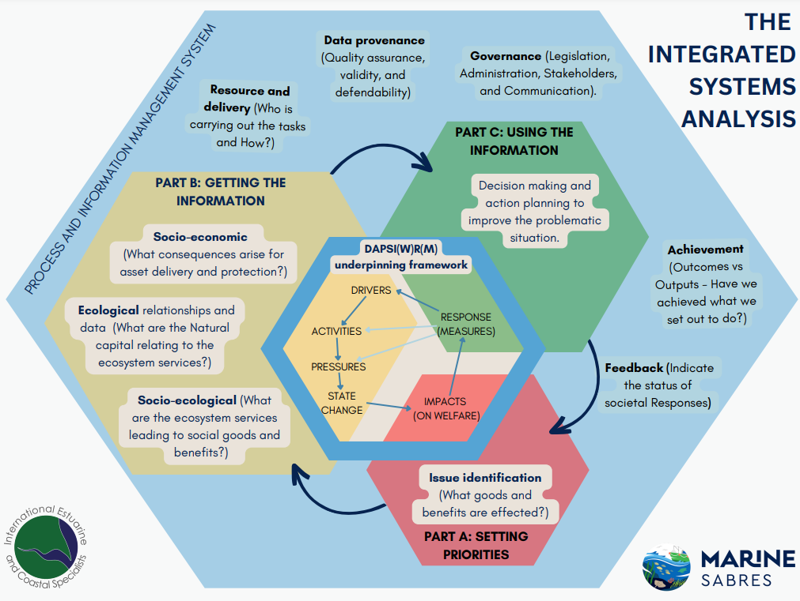

Figure 1: The integrated systems analysis, adapted from Elliott et al. (2020).

The objective of this document is to provide a step by step guide to application of the Simple SES management plan through designing and constructing the Simple SES for application within the DAs. This guidance document is supported by briefing papers on the cross-cutting themes as a deliverable of Task 3.2, within Marine SABRES project. Structured in three parts, this document gives an overview of the Process and Information Management System with relevant steps to undertake to ensure that credible and legitimate project foundations are in place (Part 1). This is followed by an overview of the ISA process and the relevant need-to-know information (Part 2), then a step-by-step guide of the ISA analysis is provided (Part 3) accompanied by supporting information on systems approaches used, frequently asked questions, and further resources (Appendix 1 and the Briefing Papers).

## Part I: The Process and Information Management System

This section of the guide provides an overview of the various frameworks and approaches compiled to work together in an ISA; the literature review that informed the design of the SES will be found on the Marine SABRES SharePoint in folder T3.1 under WP3 once reviewed. These various approaches were determined by the literature review aforementioned and comprise of systems thinking concepts to help operationalise the SES. The Process and Information Management System (PIMS) is an encompassing system within the ISA approach which directs management to consider logistically and multi-sectoral considerations of marine management.

### Using the DAPSI(W)R(M) Framework for Issue Structuring

Marine and estuarine management operates at the interface between natural and human systems. The Marine SABRES project explicitly recognises the complexity of such systems and the multiplicity of stakeholders involved in the marine and estuarine context. Good management is based on having the best possible understanding of the system or systems that one is trying to manage but, given the multifaced nature of marine and estuarine systems, no one stakeholder or stakeholder group has a privileged position that offers a holistic view. Each stakeholder’s view is limited and it is only by bringing stakeholders together to share their views of marine and estuarine systems that a more holistic view can be approached. Consequently, the processes of identifying and engaging stakeholders, enabling stakeholders to articulate and share their knowledge of the system (often referred to as issue structuring), critically managing information, and governance become paramount and are reflected in the interpretation of the Integrated Systems Analysis approach detailed in this guide.

At the heart of the Integrated Systems Analysis approach is the DAPSI(W)R(M) model (pronounced *dap-see-worm*) (Elliott et al., 2017a), based on the identification of:

* **D**rivers – the human needs and wants such as food, shelter, security, life fulfilment, etc.
* **A**ctivities - the means of obtaining those human needs, such as fishing for food or observing a scenic view.
* **P**ressures - the mechanisms of change in the natural or human systems emanating from the activities, such as physical disturbance to the seabed.
* **S**tate changes - the degree of change on the natural system and ecology resulting from the pressures e.g. erosion and turbidity leading to reduced fish populations.
* **I**mpact - on human **W**elfare e.g. reduction of fish catch per unit of effort.
* **R**esponses - using management **M**easures and the amendment or creation of policies, along with behavioural changes e.g. seasonal closure, changes in net size, and changes in consumer purchasing behaviour towards more eco-friendly goods.

Originally the DAPSI(W)R(M) diagram was given as operating counter-clockwise due to the logical chain of one element giving rise to or affecting the next (see Figure 2). It is suggested here that in any investigation of a complex marine issue, the model be used in a clockwise way (see Figure 3) with Impact on human welfare being the starting point, as changes in it are often the motive for an investigation of the system and stakeholders can have strong views of how changes in the system have affected the availability of societal goods and benefits. Further information can be found in the DAPSI(W)R(M) briefing paper (*BP3:The overall DAPSI(W)R(M) Framework*). The implementation of the current guidance can eventually be linked to the stakeholder-created mind-maps following the WP 2 stakeholder interviews.

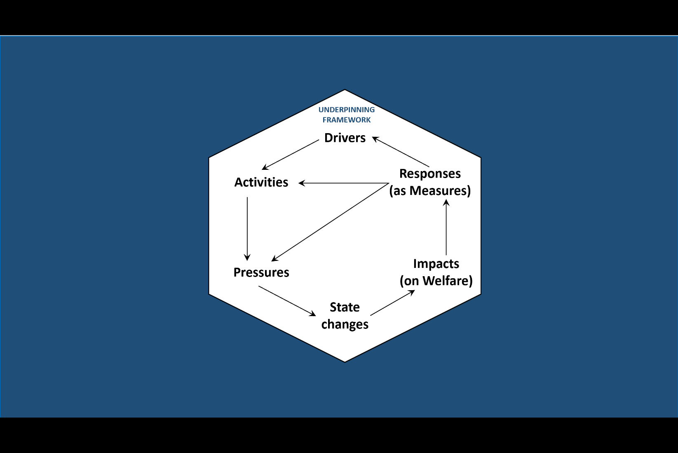 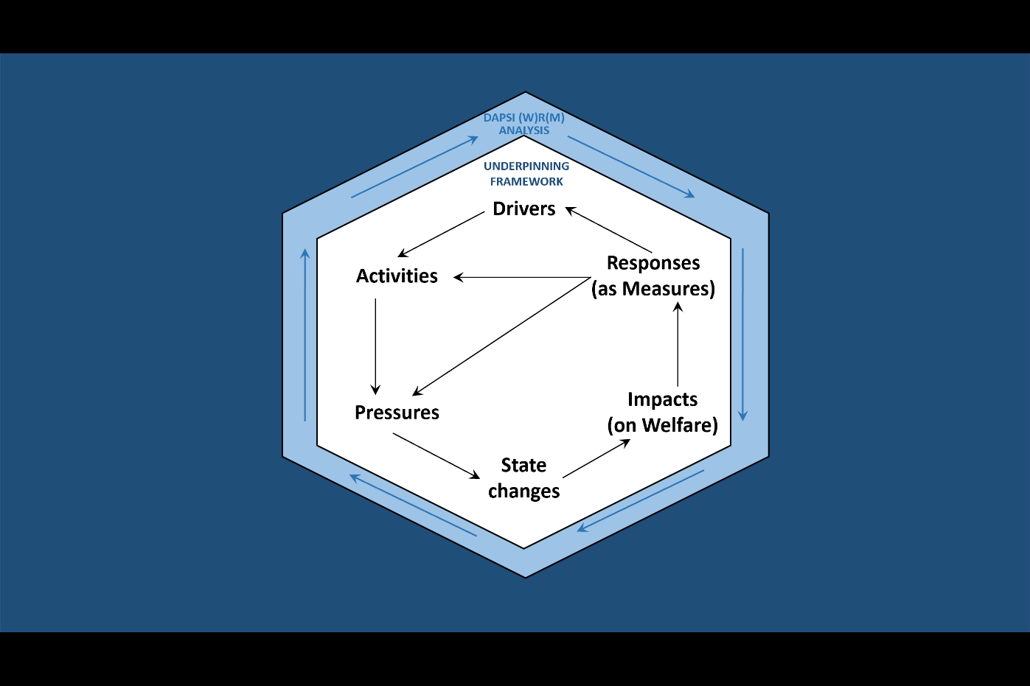

Figure 2: The original counter-clockwise DAPSI(W)R(M) Framework. Figure 3: The proposed clockwise DAPSI(W)R(M) Framework analysis.

This guide is designed to enable Demonstration Area (DA) participants to conduct a DAPSI(W)R(M) analysis in a step-by-step way and, in so doing, to generate the necessary data and information. As such, Excel spreadsheet templates have been created to record these data. It is suggested that a lead member of the DA group takes responsibility for creating and updating the data spreadsheets. The DAPSI(W)R(M) framework is then used as the basis for a three-part process, an Action Learning Cycle (Zimmer, 2001), (see Figure 4), to investigate and to improve the system under study; this is summarised as Part A – Setting priorities, Part B – Getting the information, and Part C – Using the information.

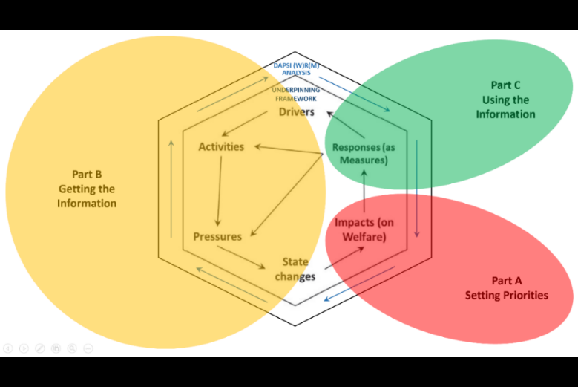

Figure 4:The DAPSI(W)R(M) based Action Learning Cycle (Unpublished, Atkins and Gregory, 2023)

### Process and Information Management System (PIMS)

The PIMS is a crucial component of an Action Learning Cycle (Zimmer, 2001), because it plays a vital role in maintaining good governance and ensuring information provenance and management throughout the process (Figure 5) (BP10: *Process and Information Management System)*. The PIMS encompasses six key elements, each requiring inputs from the DA participants alongside WP4 to create a successful and sustainable management system:

1. DA project management
2. Resource management
3. Stakeholder identification and engagement
4. Communication and impact management
5. Data provenance and management
6. Evaluation
7. Governance

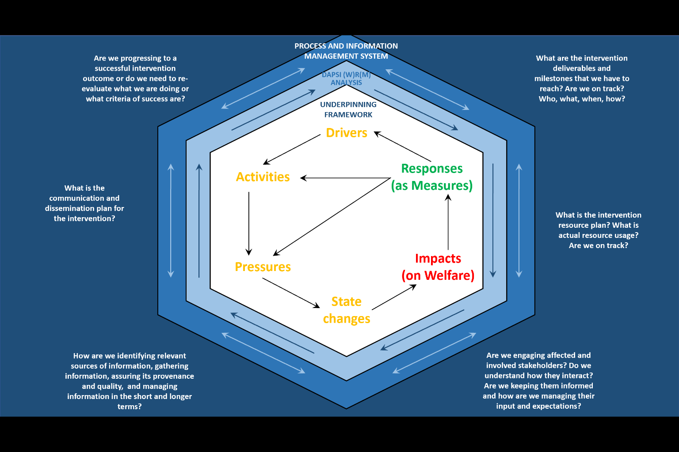

Figure 5: The PIM System surrounding considerations for the ISA analysis (Unpublished, Atkins and Gregory, 2023).

These six aspects are explained within this section. A corresponding PIMS Excel sheet provides templates and tables, such that completing these Tables/Tasks/Considerations gives a reliable, and organised foundation to analyse the social-ecological system (SES) of the DA and its component areas (Figure 6).

The Excel document allows a tick box style to indicate the progress of completion of the tasks. All necessary information to complete the Excel workbook is found within this section of the guidance.

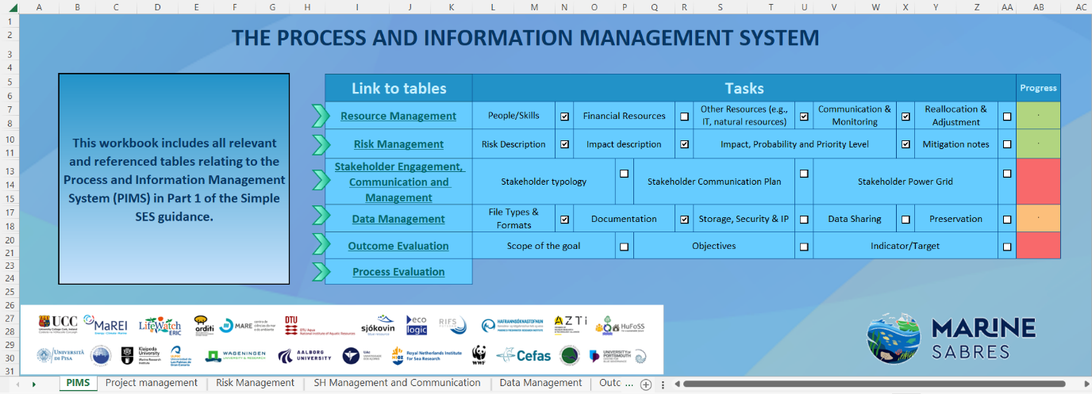

Figure 6: The process and information management system, enabling completion of the Social-Ecological System (SES) for each DA or component area.

### Demonstration Area Management

In essence, the Marine SABRES project aims at defining a Simple Socio-Ecological System (SES) that can be used either for the whole of each case-study area, the Demonstration Areas, or, in the case of the Arctic Northeast Atlantic and Macaronesia DAs, the three component areas. The actions in this guidance aim to allow the proposed management plan for the DA or its component areas to be derived and tested as based on the underlying SES. The SES chosen after review is the Integrated Systems Analysis (ISA) which is regarded here as an action learning cycle with the output from one iteration of the cycle becoming the input for the next. As a consequence, ISA is regarded as an ongoing process rather than typical project management as a one-off undertaking. However, as each of the DAs is carrying out an iteration of the ISA action learning cycle, it is appropriate to refer to DA Management and relevant to draw on project management best-practice with each iteration of the ISA cycle being managed according to the processes of initiation, implementation and closure.

#### Initiation Phase

Each area requires an area problem-definition statement to be defined indicating the main challenge (the goal or vision) in the management of the area (i.e. a definition statement that can be derived by and/or shared with stakeholders). That statement should be broken down into objectives (e.g. Table 1) and identify the key people involved, resource availability, the key tasks and the duration of the management actions as well as benefits (progress towards the vision). Many of the management actions in the initiation phase are also associated with Part A of ISA, such as stakeholder identification and engagement and their initial definition of evaluation criteria (i.e. what successful management looks like or what difference such environmental management is intended to achieve(for example Table 1)).

Table 1: An example of the three DAs (the Tuscan Archipelago, Arctic Northeast Atlantic, and Macaronesia) overall goals. Complete this table in the PIMS Excel under ‘outcome evaluation’ and tailor the goal to your management plan.

|  |  |
| --- | --- |
| **DA Sites** | **The broad scope of the goal** |
| The Tuscan Archipelago | Tourism and conservation of seagrass beds: We will restore seagrass beds by finding alternative mooring solutions. The recovery of seagrass beds from physical disturbance will be assessed by replicated diving surveys to assess the recovery rate in terms of biodiversity, protection from invasive species and carbon sequestration. Measures to promote more sustainable mooring and boat use across private users and commercial charter companies will be developed. |
| Arctic Northeast Atlantic | Impact of climate change and challenges surrounding commercial fisheries: The focus will be on important species, including both commercial species (e.g. mackerel, capelin and cod) and demersal fisheries (e.g. cod, capelin) and those with particular conservation value (e.g. marine mammals and elasmobranchs). We will examine the effects of climate change and changing oceanographic conditions to identify likely shifts in species distribution and abundance and potential areas of conflict. Together with stakeholders, we will also examine the capacity of communities to respond to environmental change and identify and implement the measures required to change human behaviour. |
| Macaronesia | Conservation and restoration of biodiversity and the benefits of ecotourism: The focus will be on both benthic habitats, non-migratory species and locally successful protection measures, as well as migratory species (e.g., marine mammals, sharks, tunas, seabirds) whose habitat straddles the three island groups and which provide different types of societal benefits. Existing coastal restoration and conservation projects in Macaronesia will be analysed to identify the quantitative benefits of restoration to tourism activities, including the bird and marine mammal watching sectors. Lessons learned will be transferred to the application of a region-wide effort to develop a biological conservation corridor for migratory species such as cetaceans, seabirds and fishes. |

#### Implementation phase

The implementation phase relates to tracking the progress and managing the DA or its component area thereby using the definition statement to create a management plan which defines what needs to be done, by when and by whom and allocates available resources accordingly. The management plan is the central document that is used for the duration of the management cycle; this entails getting agreement and acceptance from all participants on aspects such as the project milestones, phases and tasks, as well as who is responsible for each task, associated timelines and what deadlines are to be met. Gantt charts may be useful to support the management plan. Implementing a management plan requires:

**Risk management:** Following creating the management plan, it is important to assess any factors that could prevent the ability to meet deadlines (Figure 7), for example, personnel changes. A risk log can be used to record and grade risks and hence it carries an associated action plan to minimise the identified risk. This may be linked to issues management and as such refers to concerns related to the project raised by any stakeholder. In the absence of any other risk log in place, the template on the ‘Risk Management’ sheet of the PIMS Excel workbook can be used.

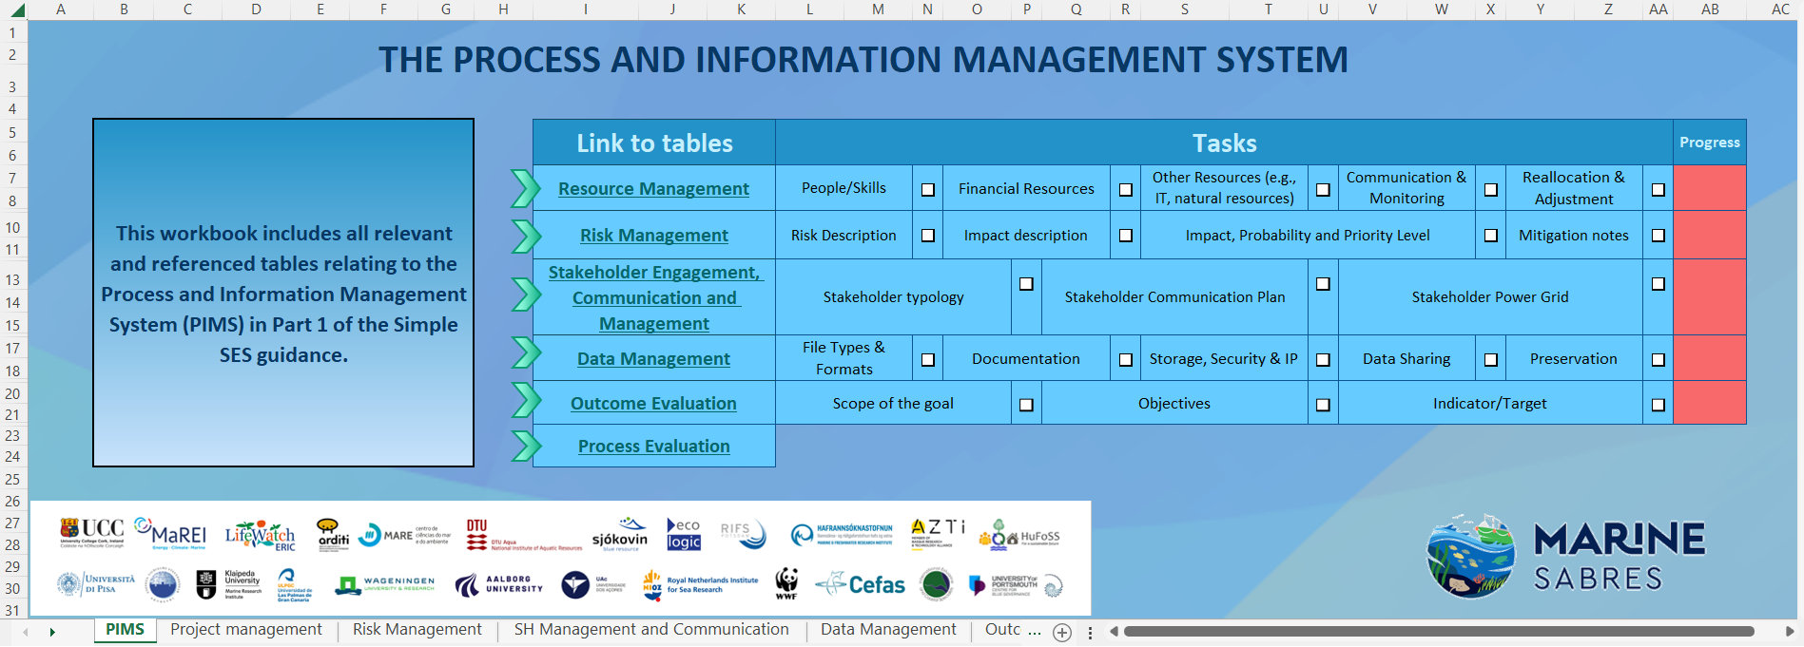 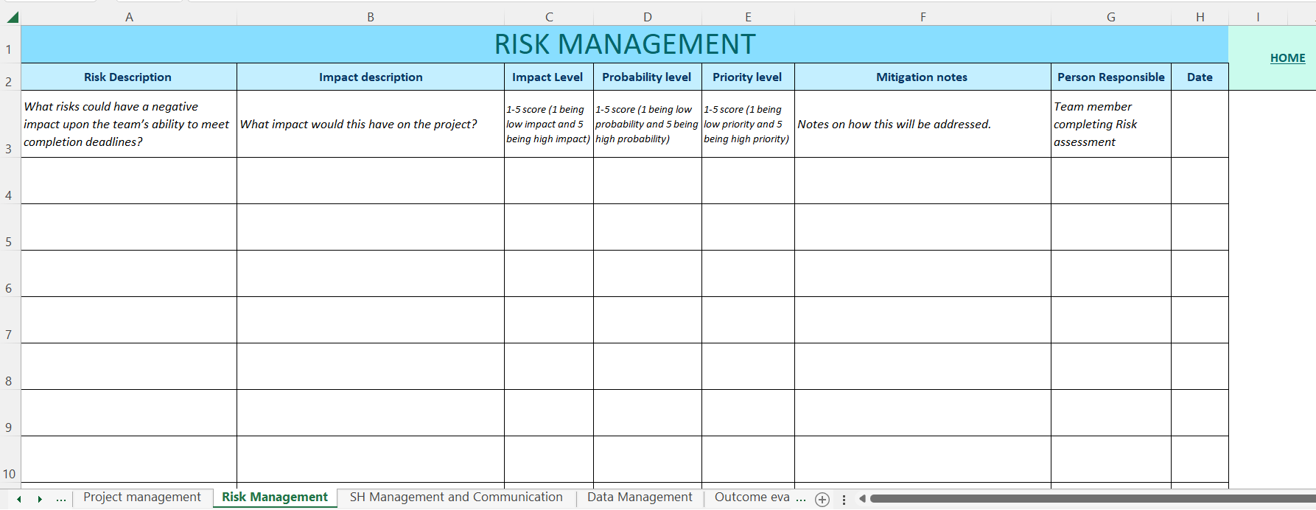

Figure 7: Screen-shot indicating the position of the Risk Management item template.

**Quality control:** this identifies the quality of the tasks and it ensures that relevant standards are met e.g. data management and General Data Protection Regulation (GDPR) specific to the area management; this is detailed further in the data provenance section but also in the Data Management Plan for the Marine SABRES project.

**Progress control:** Is the monitoring of the management plan and the production of regular progress reports to communicate the progress of the management plan to relevant stakeholders of the project. As most management plans encounter challenges, , it is important to review the direction of the management plan and monitor the degree to which the plan is followed and take appropriate action if there is a deviation by employing regular progress tracking. This is achieved by having established, and recorded in the management plan, regular checkpoints during its duration. Further guidance is given in Resource Management and Evaluation sections.

**Change control:** Is necessary because few projects go exactly to plan so changes will need to be made to the length, direction and type of tasks carried out by the team. Such changes should be documented by the team along with the likely impact on the project if the change is to be implemented (e.g. will it affect the finish time of the project, will the project run over budget, are there enough resources) and then informing relevant stakeholders of the implications and alternatives that the request for change has identified.

The implementation phase ends once the project has achieved its objectives as outlined in the definition statement.

#### Closure phase

The purpose of a formal closedown to the project is to address all issues generated by the project, to release team members from the project and go through a 'lessons learnt' exercise. At this phase, it may also be necessary to gain a formal sign-off on the project as confirmation of its completion. A review meeting by the team to formally end the project is recommended to go over any outstanding issues such as ongoing maintenance, the closing of project files and to conduct an evaluation or team review of how well the project has performed against the original definition statement and also the stakeholder-generated criteria of success. As ISA is an ongoing learning cycle, the team may also reflect on the process (e.g. what did we do well, what mistakes did we make) so that the team can learn from this project and make further iterations of the cycle more successful; further detailed in evaluation.

### Resource management

Resource management is the efficient and effective development of resources when they are needed. Such resources may include financial resources, inventory, human skills, production resources, information technology (IT) and natural resources. When you are in the initiation phase, you need to know what specific resources will be required to execute the project such that specified objectives are met (Figure 8).

The first step in resource management involves determining resource requirements, which include people, skills, and finances. All required resources should be identified, secured, and allocated across the different phases of the project with budgets agreed upon by the team. The next step in resource management entails managing the assembled resources by clearly defining and communicating roles and responsibilities. Maintaining consistent, transparent communication is vital to ensure that team members have an up-to-date understanding of individual tasks and timelines throughout the project's lifecycle. Throughout the project, continuous monitoring of resource usage is essential. If necessary, resources may need to be reallocated, and any changes should be communicated and agreed upon by the team to support the successful completion of the project. To document these steps, complete the resource management table in the PIMS Excel document to organise the account for relevant resources for the project.

 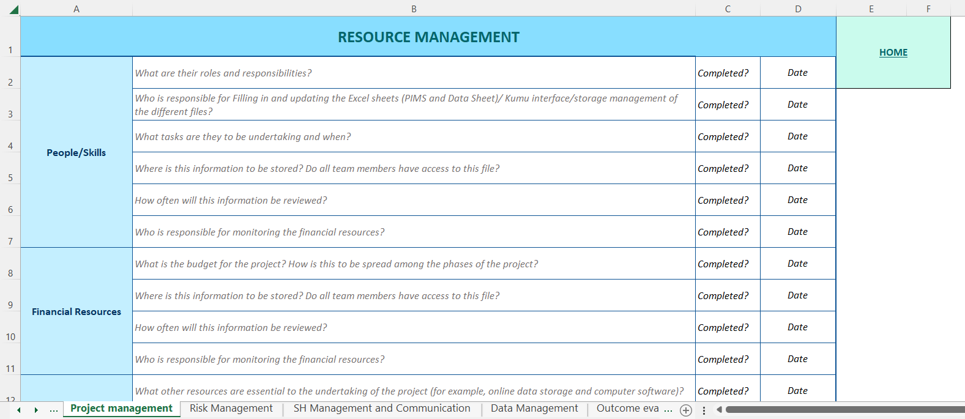

Figure 8: Screen-shot indicating the position of the Risk Management item template within the PIMS Excel.

### Stakeholder identification and engagement

When taking a systems approach to the marine environment, which is a complex and multifaceted system, it is impossible to comprehend the whole system, hence we make boundary decisions to aid simplicity and clarity. Boundary decisions mean defining what or who is relevant and included inside the boundary and relegating that or those considered irrelevant and excluded from the environment. This method of stakeholder identification and engagement sets the scope of the analysis.

Defining boundary decisions involves determining which elements or individuals are relevant and included within the boundary while excluding those deemed irrelevant. This practical aspect is crucial, as wider boundaries require more time and resources for analysis, yet they yield greater benefits, particularly in terms of expanding the knowledge base. Therefore, it is essential to strike a balance between costs and benefits in a defensible and transparent manner. Accountability is important in this context because the individuals or elements included within the boundary have a say in shaping improvements(and by association, evaluation of the intervention). This includes defining the appearance of the improvements, setting objective(s), and determining how the intervention is designed to achieve desired outcomes.

An almost inevitable implication of being aware of boundaries is the need to adopt a multi-stakeholder perspective. Meaning, we are being critical about who the client for the intervention is, going beyond any singular commissioning group, and also relying on generic stakeholder lists in order to suggest identifying who the stakeholders really are in the specific situation. Hence, we are not merely seeking to continue existing relations in terms of who is involved but to ask the more critical question of who ought to be involved with due consideration to equality, diversity and inclusion (EDI) (BP13: *Equality, Diversity and Inclusion*).

Our approach to stakeholder engagement is critical and based on a set of principles (see Table 2) that require reflection and discussion of what constitutes both justifiable and pragmatic boundaries of engagement. In multi-stakeholder settings, conflicts of interest are addressed, ideally, through procedures considered fair by all, while recognising that there may be no quick solution to the focal issue.

Table 2: Stakeholder principles and implications (Gregory et al., 2020 based on Pouloudi et al., 2016)

|  |
| --- |
| **Stakeholder principles recognise that:** |
| 1. The set and number of stakeholders are context and time-dependent |
| 1. Stakeholders may have multiple roles |
| 1. Different stakeholders, even within the same group, may have different values and perspectives, which may be explicit, implicit or hidden |
| 1. Stakeholder roles, perspectives and alliances may change over time |
| 1. Stakeholders’ relations and power matter in the shifts in their roles, perceptions and alliances |
| 1. The definition of stakeholder groups for inclusion also represents boundaries of exclusion and marginalisation |
| 1. Causes and issues from which stakeholders derive a sense of identity from may affect trust, co-operation and value creation in an issue-based stakeholder network |
| 1. Researchers and funders are stakeholders too, and they may be surrounded by other stakeholder groups with associated interests |

Newton and Elliott, (2016) highlight various different types of stakeholders in the marine environment that may be relevant to the DA projects. Firstly, there are those creating the marine pressures (the ‘inputters’ and the ‘extractors’ – respectively those who put waste, structures, land-claim, etc., into the sea, and those who remove resources such as space, fish and shellfish, seabed and water, from the sea). Next is the ‘regulators’ which include those who have a duty to control these potentially-damaging activities, these stakeholders may be found in the administration analysis as part of the governance briefing paper. The ‘affectees’ are the parts of society affected by these activities and regulations, either positively or negatively, and the ‘beneficiaries’ are those who benefit from the uses and users of the seas (e.g. a coastal community benefitting from tourism in the marine environment).. Finally, the ‘influencers’ are the policymakers, politicians, educators, researchers and lobbying groups (e.g. environmentalists, conservationists) who attempt to control the behaviours of the other stakeholders (Newton and Elliott, 2016). It is of note that some bodies, such as a port authority or fishing cooperative, can be included in all of these types of stakeholders.

For more information on identifying and engaging stakeholders, please refer to the briefing paper (BP14: *Stakeholders and Stakeholder Consultation).* To document stakeholders to include, complete the ‘Stakeholder engagement, communication and management sheet in the PIMS Excel workbook (Figure 9).

### Communication and impact management

Effectively engaging with stakeholders requires giving attention to how stakeholders are identified and engaged. It also means giving appropriate consideration to what information is disseminated, to whom and in what form, and about recognising political/power alliances and identity impact on the construction of understandings of the context, focal issues and stakeholder interactions.

Ackerman and Eden (2011) suggest the need for stakeholder management strategies that specify “when and how it is appropriate to intervene to alter or develop the basis of an individual stakeholder’s significance” (p.180). For this purpose, Ackermann and Eden (2011) suggest the use of a power/interest grid (see Figure 9).

The four quadrants of the grid can be seen as defining four categories of stakeholders. Stakeholders in the upper two categories are those with the most stake (i.e., most ‘interest’) in the issue but with varying degrees of power: those to the right-hand side enjoy more power, i.e. they have ‘influence’, but may or may not actually be concerned about the issue. ‘Players’ are those interested stakeholders who also have a high degree of power to support (or to sabotage) the outcome of the intervention, whereas ‘Subjects’, while interested, have less influence. The two lower categories can perhaps be seen more as ‘potential’ stakeholders who have not (yet) displayed much interest in the issue. ‘Context setters’ may have a high degree of power over the future of the issue, particularly in terms of influencing the future context within which responses (plans, policies, etc) will need to operate. The last quadrant, the ‘Crowd’, (currently) exhibits neither interest in nor power to influence the issue of concern.

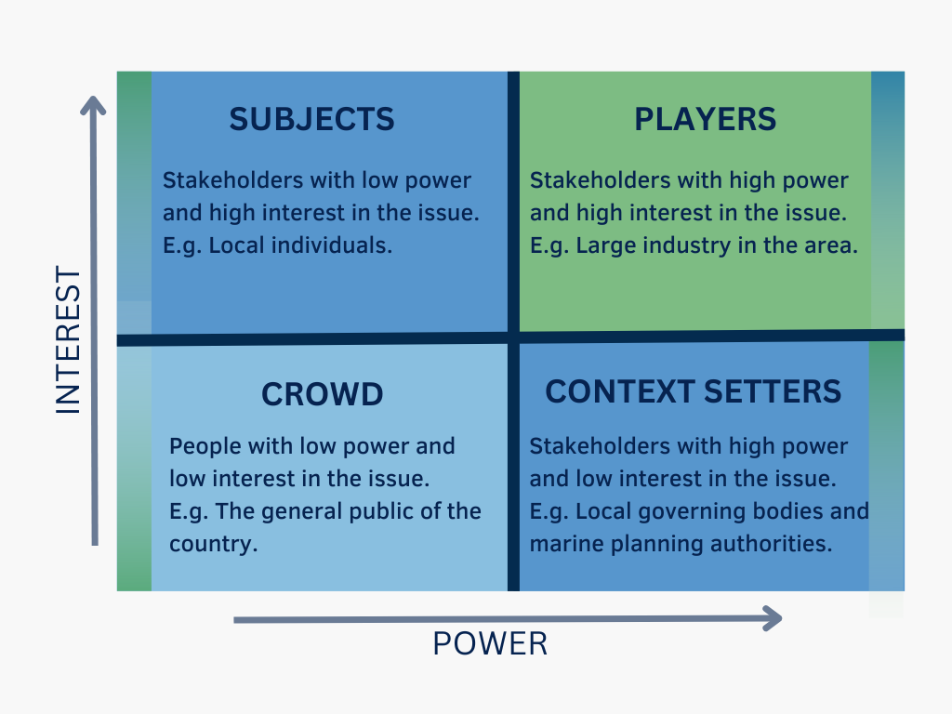

Figure 9: Stakeholder Power-Interest Grid redrawn from Ackermann and Eden (2011).

When stakeholders respond to a particular action they do so with reference to other stakeholders and how they might respond. Exploring the impact of stakeholder relationships stems from the extensive literature on social networks. One stakeholder’s actions can generate a dynamic of responses across a range of other stakeholders. Indeed, Fliaster and Kolloch (2017, p.698) suggest that *“stakeholders are likely to orchestrate their activities and thus develop a much stronger bargaining power. Furthermore, some stakeholders do actively search for coalition partners that can help promote their particular agenda and exert additional impact”*. In the same way a stakeholder’s power can often be described in relation to their position in the network of other stakeholders.

This interactional aspect of stakeholder analysis can be depicted as a ‘Stakeholder Influence Network Diagram’ which aims to surface both the formal and informal relationships that are the bases of such social networks (later we will recommend the software package Kumu and it is worth noting that this can be used for social network analysis). Taking stakeholder disposition (positive or negative) into account reveals potential opportunities and dangers. A centrally-located stakeholder, with many links both in and out, who is perceived as being negatively disposed towards the intervention can have a significant detrimental impact (via their influence over others), so it is critical that they are successfully managed. In this case, the obvious options are to attempt to change their negative disposition and/or to reduce their power.

When considering stakeholders, it is beneficial to acknowledge that different stakeholder groups may have different communication traditions and preferences. The general public, policy-makers and politicians may want very brief information (sound bites, headlines, tweets and one-page briefing notes). In contrast, specialists may create a large amount of (often unsuitable) material (theses, reviews, scientific papers, consultant reports) which then needs ‘interpreting’ and usually summarising for the public and politicians (the so-called ‘dissemination diamond’; Elliott et al., 2017b). It is frequently argued that different disciplines and different sectors are ‘not talking the same language’ (Ostrom, 2009), so a stakeholder-based communication strategy is necessary to support, if relevant, conflict resolution and thus enable complementarity between stakeholders. The various stakeholders have to be included in all aspects and there should be feedback loops to ensure that they can receive information, act on it and have an influence (as in theory should be the case in all Environmental Impact Assessments; Glasson and Therivel, 2019).

Logistical considerations for engaging stakeholders should include:

**When they are contacted**: ideally after ethical considerations, but early enough to be included throughout the process.

**Why they are contacted:** Through written communication to gain their consent and advise how communication will take place throughout the process.

**How they are contacted:** Considerations for the minimising time of stakeholders used, the design of communication should account for stakeholder fatigue by proper planning and considering compiling questionnaires and limiting the number of workshops.

For further information on Stakeholder communication and managing impact please refer to the Stakeholder briefing paper (BP14: *Stakeholders and Stakeholder Consultation*). To explicitly map stakeholder power and address communication styles, please complete the ‘Stakeholder engagement, communication and management’ sheet in the PIMS Excel workbook (Figure 10).

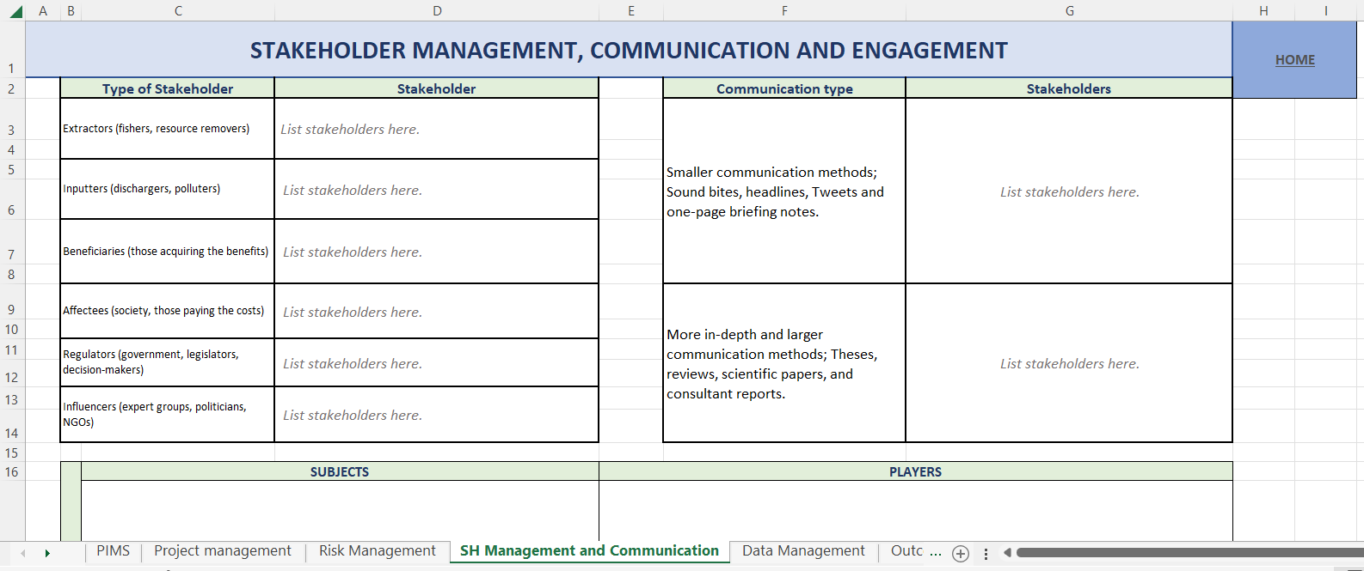

Figure 10: Screen-shot indicating the position of the Stakeholder, communication and engagement. Excel sheet in the PIMS workbook

### Data provenance and management

Data provenance centres around the assurance of a defendable knowledge-evidence base of data, and its conversion to information and knowledge that includes conventional laboratory and field science as well as traditional knowledge (i.e. indigenous knowledge) (Kaiser et al., 2019), and citizen science generated knowledge.

A data management plan (DMP) is a written document outlining the plans for managing research data both during and after the project. The Marine SABRES project has an overall DMP which we recommend to be referenced in ensuring the DA application is in line with this Marine SABRES approach to GDPR and data provenance (this document can be found on the Marine SABRES SharePoint). The plan should address what types of data will be collected and how the data will be documented, stored, shared and preserved. Within the PIMS Excel workbook, a DMP template is available to use if you do not have one in place already.

**REMEMBER:**

The cost of data sharing and management should be included in your resource management plan. This may include people, equipment, infrastructure and tools to manage, store, analyse and provide access to data. In summary, consideration needs to be given in the resource plan to:

* Collecting and 'cleaning' new data
* The analysis of newly-acquired and legacy data
* Ongoing data curation and preservation
* Providing access and data sharing.

Further information: A Guide to Research Data Management (2021) (<https://bl.iro.bl.uk/concern/generic_works/986a209d-d124-4509-a0f2-06248994149d?locale=en>), from the British Library.

To explicitly consider and document relevant data provenance and management aspects, please complete the ‘Data Management’ sheet in the PIMS Excel workbook (Figure 11).

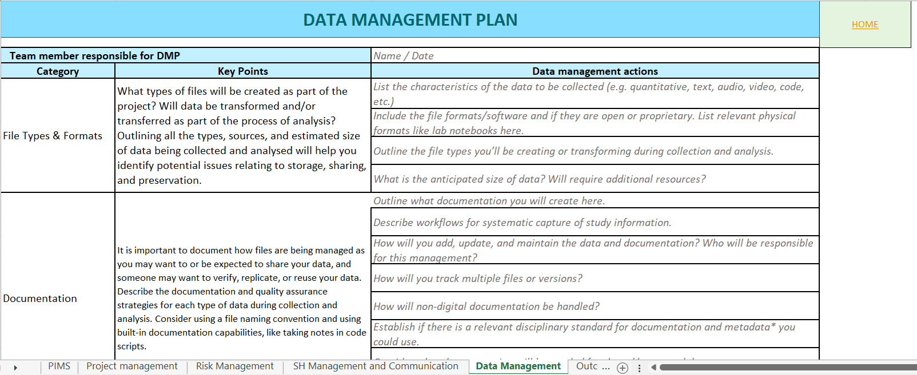

Figure 11: Screen-shot indicating the position of the data Management Excel sheet in the PIMS workbook.

### Evaluation

Participants in a multi-stakeholder setting usually define their own evaluation criteria in relation to specified goals and objectives. In terms of the ISA process, we have to think of evaluation as involving two considerations:

#### Process evaluation

Given the need to assess various stakeholder perspectives about the value or merit of the process (also known as value claims) within the process context, there is a need to assess whether participants felt that their voices had been heard. Rouwette (2011) suggests that it is important to evaluate the extent to which the intervention served to ‘improve communication between decision-makers, foster consensus and create commitment’.

This evaluation may take the form of a short questionnaire covering topics such as communication (if all participants contributed to the discussion), consensus (if participant opinions converged as they discussed options for their respective positions), commitment (what was the participants’ level of engagement with the analysis exercise?), and final messages (what was learnt?). A draft evaluation questionnaire is in the ‘process evaluation sheet’ in the PIMS Excel workbook (Figure 12).



Figure 12: Screen-shot indicating the position of the Process Evaluation Excel sheet in the PIMS workbook.

#### Outcome evaluation

The overall aim of ISA is to create Response Measures that are accepted by decision-makers and implemented in the form of amendments to existing or newly required policies, laws, etc. with the overall aim of achieving the requires objectives and vision. The definition statement should contain the goal and specific objectives of the marine management plan. Each objective should not only be SMART (Specific, Measurable, Achievable, Realistic and Time-bound) but also spatially bounded (local/national/international) together with indicators (proxy measures) identified whose change can be measured against reference or baseline conditions .

It is axiomatic that management requires assessment, measurement and monitoring against desired conditions which may the baseline or reference condition. In common with being SMART, the desired final state should be time-defined, with appropriate intermediate assessments to check progress. The information necessary to assess the state of the indicator should be determined and who and how this will be collected and analysed (this should also form part of the DA marine management plan with necessary resources to support the evaluation being allocated). In essence, this should assess whether the vision and objectives set for the management area are achieved by the proposed management actions.

It is emphasised here that all of these attributes, even if general, require indicators otherwise it is not possible to determine if the management has had the desired effect. For example, community structure requires indicators for the level of biodiversity (such as species richness, and presence of alien species); human health status can be determined through indices of welfare and well-being (Biedenweg et al., 2016; Breslow et al., 2016), and societal benefits can be measured in terms of the amount of cultural heritage, recreational opportunities and fish caught, among others.

Given the above, DA participants should develop a set of objectives and indicators to indicate successful and sustainable marine management as indicated in the ‘Outcome evaluation sheet’ within the PIMS Excel workbook (Figure 13).

 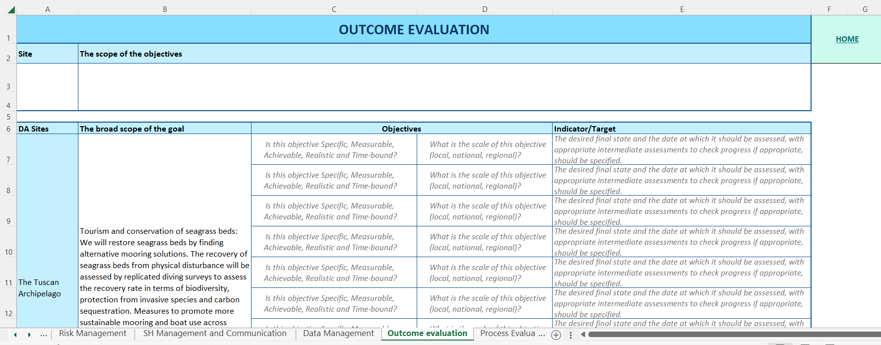

Figure 13: Screen-shot indicating the position of the Outcome Evaluation Excel sheet in the PIMS workbook.

### Governance Sub-System

Governance in marine management is defined as the sum of policies, politics, administration, and legislation. Within the EU various initiatives have been developed to promote sustainable marine management, such as maritime spatial planning, protecting marine habitats, and encouraging cross-border cooperation. The system of laws, regulations, statutes and agreements are comprised of 'hard law' and 'soft law'. Hard law refers to legally binding rules that can be enforced in a court, such as the Water Framework Directive (WFD; European Commission, 2000) or the Marine Strategy Framework Directive (MSFD; European Commission, 2008). On the other hand, soft law includes non-binding agreements, declarations, and principles that may involve legally-binding arbitration, like the Regional Seas Conventions (OSPAR and HELCOM). Boyes and Elliott (2014) gives the marine legislation complexity while Boyes and Elliott (2015) indicates the organisation complexity required to achieve those legislative instruments; Cormier et al. (2022) indicate the vertical and horizontal integration across those management responses (see BP11: *Governance/ Legislation*).

While international agreements such as UNCLOS or Regional Seas Conventions may not result in legal proceedings but possibly arbitration, for EU members the Directives are legally binding on Member States and can result in infraction proceedings in the European Court of Justice if breached. Following the Single European Act, these are then enacted by Regulations within a Member State. Those national laws then apply to individuals or organizations within the country, with sanctions through the country legal system. For those nation states in MarineSABRES not in the EU, they require their own means of following the European Directives. Irrespective of EU membership, all nation states require integration of laws and regulations at different levels: local, national, regional, and global. This vertical integration ensures a comprehensive legal framework for managing marine resources.

Fulfilling the competing legislative requirements for comprehensive and holistic marine management also requires horizontal integration in which instruments are coordinated across the sectors (fishing, aquaculture, sea-bed mining, navigation, etc.) (Boyes and Elliott, 2014). Combining both horizontal and vertical integration results in a holistic, coordinated legal system that merges legally binding and non-binding instruments for managing the seas and for meeting set visions, objectives and targets (Figure 16). Moreover, it allows defining Response Measures to instigate the required change within the behaviour of the system; the Governance Briefing paper BP11 presents an exercise to collate, describe and map and understand the relevant EU policies and equivalent applicable to the relevant DA. This exercise will allow the governance horrendogram for each DA to be completed; note that these horrendograms have already been created for certain areas in the MarinePlan sister project and in other publications such as the GPSAZORES project (<https://www.gpsazores.com/media/GPSAzores_Report_WP1_ntVEqu9.pdf>).

**EXAMPLE:** *Horizontal and Vertical integration of EU Marine Management*

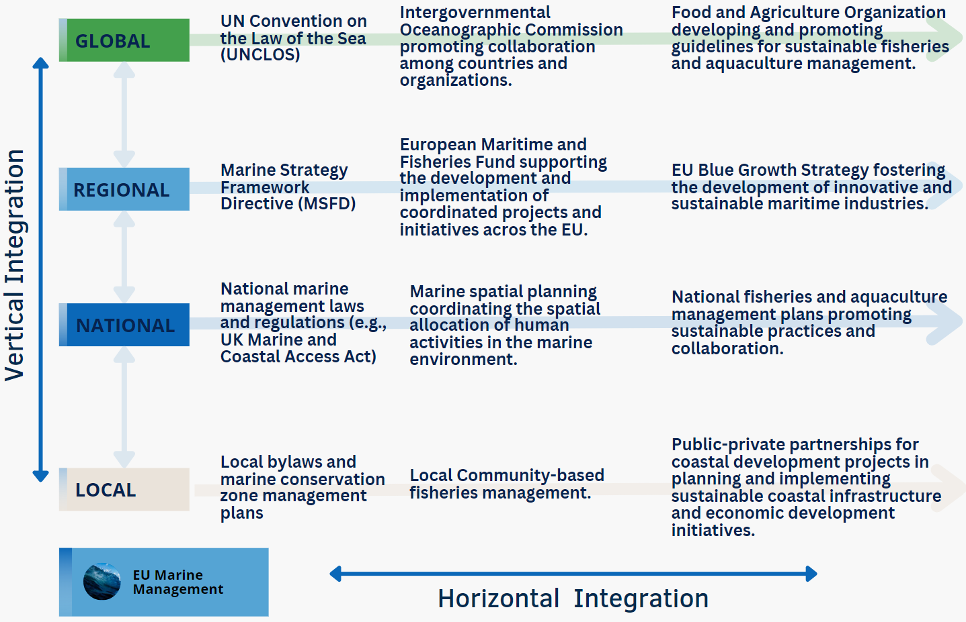

Figure 14: An example of the different horizontal and vertical applications of EU marine management (Unpublished, Smith, 2023)

The plethora of legislation then requires Administrative considerations, the national and regional bodies, agencies, departments, etc. to implement, enact and enforce the vertical hierarchy of legislation. As with the instruments under which they are constituted, these bodies (summarised as a management organogram, e.g. Boyes and Elliott, 2015) need to be coordinated and integrated horizontally to accomplish the vision and objectives described above, particularly across interested stakeholders (Stephenson et al., 2019). In many countries, marine administration is sectoral with different bodies for fisheries, nature conservation, navigation, land-based pollution and planning such as with aquaculture, etc.. There are few, if any, countries which have a single marine management organization which covers all of the sectors, hence the need for effective coordination between these bodies. The Administration Audit briefing paper (BP12: *Governance/Administrative*) requires participants gather the relevant information and create the administrative organogram for their DA.

Governance considerations within the scope of this SES look to the structures and processes in that people in societies make decisions and share power, create the conditions for ordered rule and collective power (Folke et al., 2005); more specifically the sum of the policies, politics, administration and legislation required in adaptive environmental management (Cormier et al., 2022).

## Part II: The Integrated Systems Analysis

### Overview – Integrated Systems Analysis Part by Part

Based on the above descriptions of both the DAPSI(W)R(M) and the PIMS, participants will then collate information to consider further each of the three parts of the Integrated Systems Analysis action learning cycle.

#### Part A:

Part A explores the main problem(s) to be addressed in the DA and identifies the often numerous priority issues facing stakeholders in a complex marine system (see Figure 15). While different stakeholders may perceive the problem differently, it is important to creatively explore perceptions and to further understand the situation, as a common characteristic of complex problems is that the root cause is not always apparent at first inspection, nor is the solution obvious.

An appropriate starting point is a conceptual model created by and understandable to both sets of stakeholders in MarineSABRES – the high-level ones and the DA participants. For example, the use of ‘Rich Pictures’, cartoon-like and stakeholder-led expressions of the significant problem situation (Bell. Et al, 2016). Exploration of a Rich Picture can lead stakeholders to confirm the priority issues regarding the impact on human welfare including the level (individual, regional, national or international) at which the issue symptoms are shown; this is known as the ‘system-in-focus’ covering complexity across three system levels with a system above (the meta-system) and systems below (sub-systems) the main system of concern. Although a stakeholder group in MarineSABRES WP2 is asked to focus on what are their priority issues, it would also be possible to validate perceptions through a Delphi exercise (online or through a face-to-face meeting) involving a wider group of stakeholders and a more formal prioritization process.

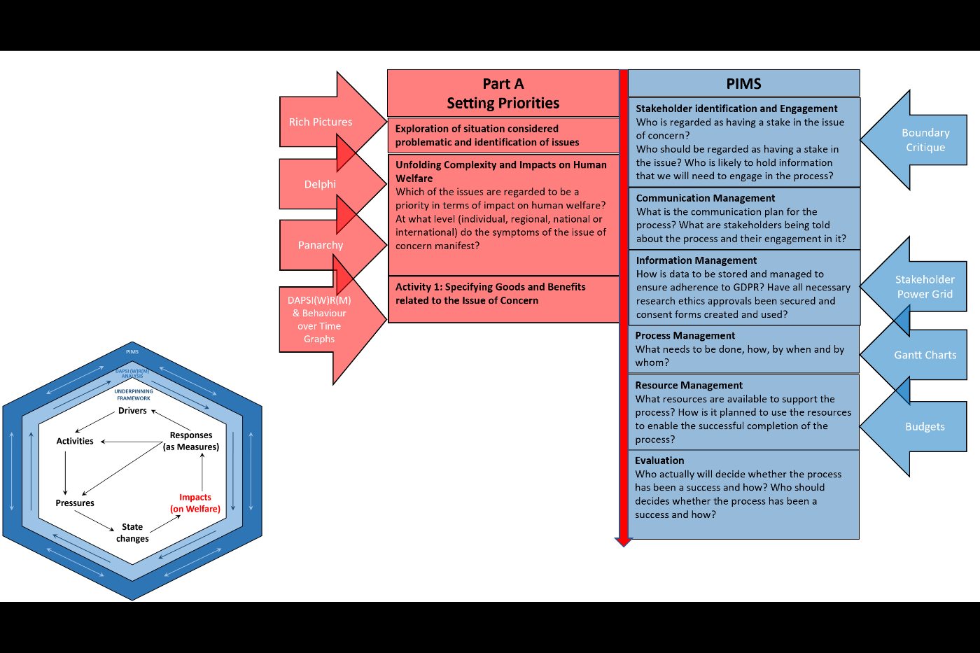

Figure 15: Part A of the Integrated System Analysis which concerns setting priorities and PIMS considerations (Project and Information Management System) (Unpublished, Atkins and Gregory, 2023).

#### Part B

Part B focusses on getting information, using the DAPSI(W)R(M) structuring method, regarding the way in which key elements of the DA system of concern (state changes in ecosystem processes and services, pressures, activities and drivers) are changing or have changed (see Figure 16). These data include indicators of the DAPSI(W)R(M) elements, over a period of time, and from multiple data points (e.g. previous and current state of an indicator). Supporting information on indicators, Ecosystem Services, Marine Processes and Functioning, and decision support tools can be found in the collection of briefing papers (BP3: *DAPSI(W)R(M) Overall framework;* BP4:*Marine Processes and Functioning and Ecosystem Services;* BP5:*Goods and Benefits and Societal Wellbeing;* BP6:*Indicators;* BP7:*EBM Tools)* which support the SES.

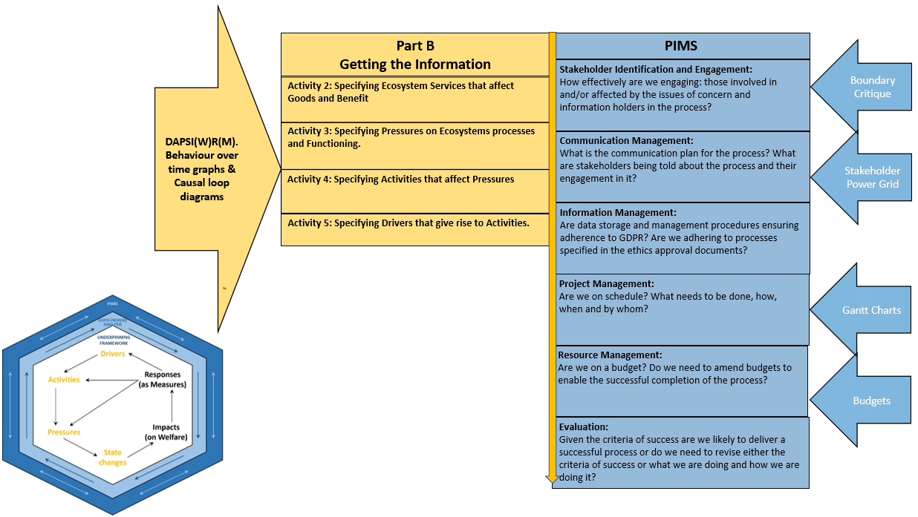

Figure 16: Part B of the Integrated System Analysis which concerns getting the information and PIMS considerations (Project and Information Management System) (Unpublished, Atkins and Gregory, 2023).

#### Part C

Part C focusses on using the information gathered to create a shared understanding of system behaviour which forms the basis of the theory of change and how we can intervene in a system achieve a desired state (see Figure 17). Given the complexity of the marine environment as an SES, it is likely to involve multiple feedback loops and data gaps’ It is important to test the robustness of policy and practice options, for example with respect to scenarios of potential futures, before giving recommendations to decision and policy makers.

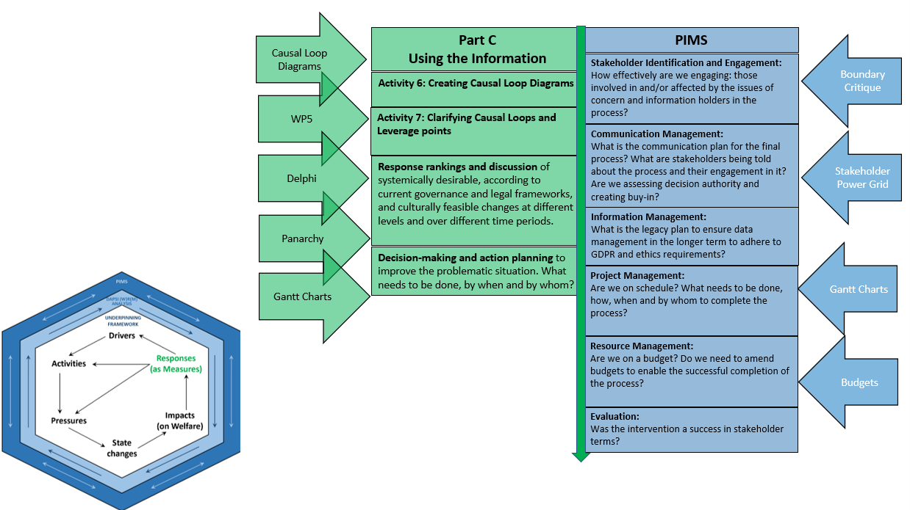

Figure 17: Part C of the Integrated System Analysis which concerns using the information and PIMS considerations (Project and Information Management System) (Unpublished, Atkins and Gregory, 2023).

### Visually Representing Complexity - DAPSI(W)R(M) and Causal Loop Diagramming

The DAPSI(W)R(M) framework (Elliott et al., 2017a), may be regarded to be either a deep structure, a driving feedback loop of how the world works, or a root mental and conceptual model, giving a feedback loop of our understanding of the marine natural and societal system (see also Elliott, 2023). Using the DAPSI(W)R(M) framework in an issue structuring mode can identify causal logic chains, which can be recorded and explored in, for example, Excel spreadsheets. While DAPSI(W)R(M) supports the rigorous investigation of the system in focus, it can be detailed; similarly , the format of Excel spreadsheets is less than a visual way that emphasises the marine system dynamics. Consequently, there is the benefit of using the discipline of systems thinking.

The discipline of systems thinking helps us understand how the parts of a system interact to give rise to emergent behaviours and properties, and sometimes, particularly when these are negative, they may be regarded as unintended consequences. An example of an emergent phenomenon in the marine environment is cumulative pressures caused by human activities; for example, while the effect on ecosystems by different types of fishing is well-known, the combined consequence with other activities such as energy production and land claim, plus the effects of climate change in on an ecosystem, is an emergent outcome of the system (e.g. Elliott et al., 2020a, 2018). The mantra of a system is more than the sum of its parts is an indirect reference to these emergent properties. Systems thinking encourages a shift away from linear cause and effect relationships to recognise that cause and effect can lead to the behaviour of a system to be complex and difficult to understand and manage (see BP9:*Systems Thinking*).

#### Causal Loop Diagrams

A causal loop diagram (CLD) is a qualitative systems-based tool that shows the relationships between a set of elements that are variables (factors liable to change e.g. indicators) operating in a system. The basic premise of causal loop diagramming is that the structure of a system should fully explain its behaviour and the process of developing CLDs can help stakeholders converge on a shared understanding of system behaviour and also how to intervene in a system, by identifying root causes and manipulating leverage points, to help to achieve a desired state. This type of systems approach was discussed in the 1960s (Forester, 1961) and has been widely used and further developed since then (e.g., Rosnay, 1979; Richardson and Pugh, 1981; Senge, 1990; and Sterman, 2000).

Causal Loop Diagramming with stakeholders has already been used extensively in marine management (see, for example, Videira, 2012 and Figure 18); MarineSABRES is innovative in seeking to combine the DAPSI(W)R(M) framework with CLD by stakeholders.

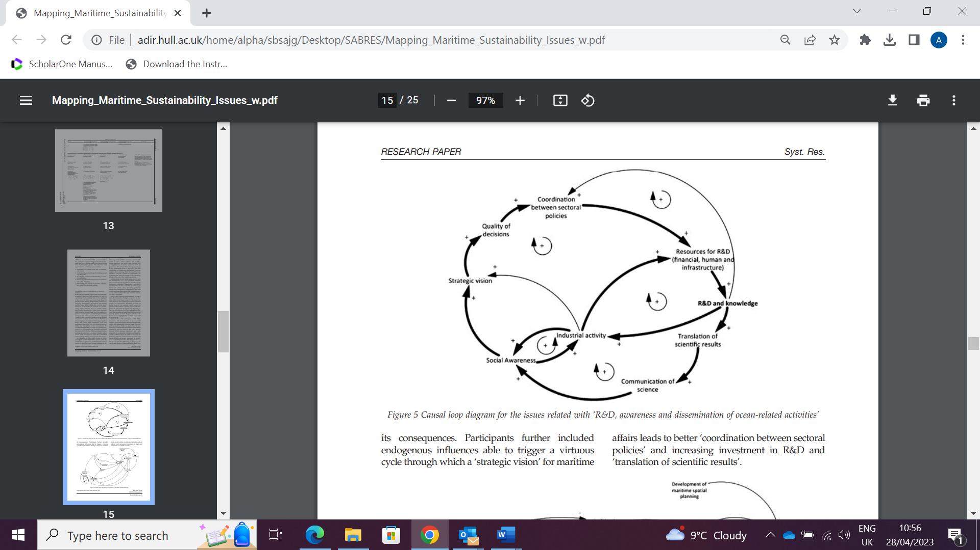

Figure 18: Causal Loop Diagram for issue of ‘R&D awareness and dissemination of ocean-related activities (Videira, 2012).

A CLD can also be the foundation for quantitative modelling techniques e.g. system dynamics, for a more robust exploration of system behaviours and testing of policy and practice options before final decision-making and implementation. Figure 19 indicates the process of CLD-based investigation and modelling. It is emphasised that here the DAPSI(W)R(M) framework is suggested as an issue-structuring approach that supports stakeholders sharing their perceptions and mental models of how the system is structured and operates. This approach is therefore analogous to the mind-maps created by high-level stakeholder consultation in MarineSABRES WP2.

Further information on constructing CLDs is given in: [*https://core.ac.uk/download/pdf/289179095.pdf*](https://core.ac.uk/download/pdf/289179095.pdf)

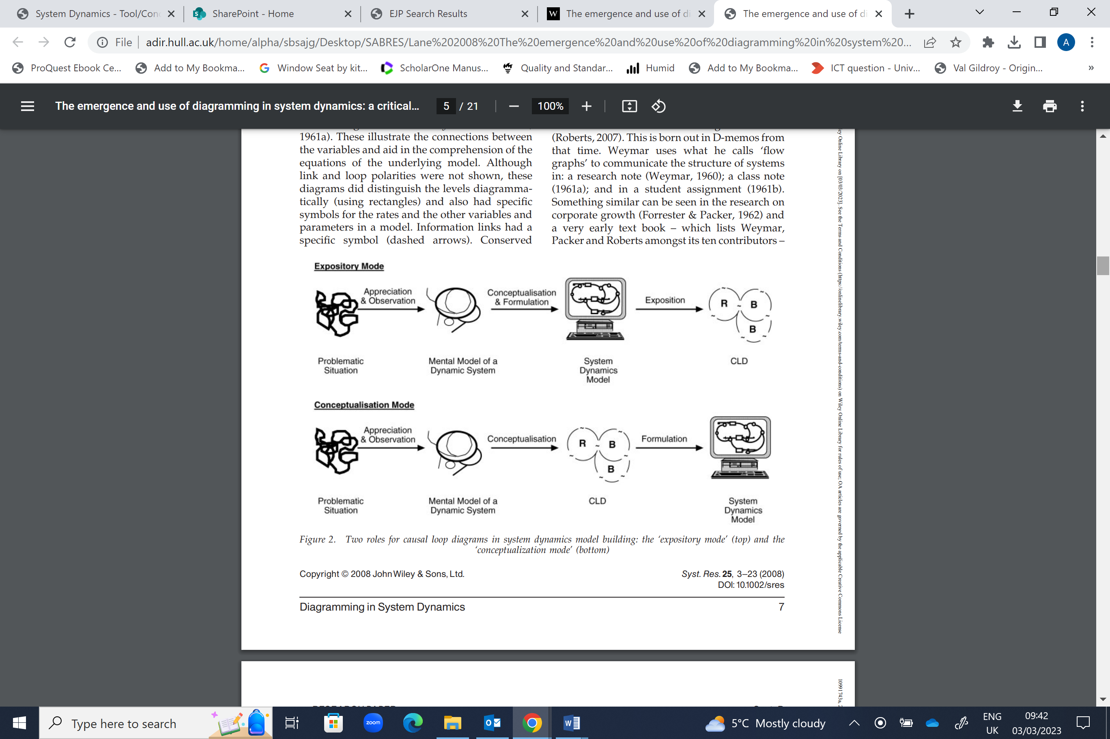Elements

Figure 19: A Causal Loop Diagram based process for issue conceptualisation and formulation (Lane, 2008)

An element is a variable that is liable to vary or change (Oxford English Dictionary). In this context, an element has two attributes: a name (what it is called) and a ‘level’ (quantity, amount, size, magnitude, value). A variable can be almost any factor in a system; it may be quantitative e.g. population abundance, or it may be qualitative e.g. cultural belief or happiness. It is important to focus attention only on those varying attributes (variables) that are relevant to the issue of concern. In a complex system there are many variables, and we can (in principle) describe the state of the whole system by reporting the levels of all of these variables but this might not be possible or even desirable—either because of the large number of variables involved, or because it is not possible to determine their levels, or both. In addition, we can distinguish between endogenous variables, both influencing and influenced by other variables within the CLD, and exogenous variables, influencing but not being influenced. These are analogous to endogenic pressures, in which marine management addresses both the causes and consequences in a management area, and exogenic pressures, in which the causes are outside the area but the consequences are inside the management area and hence need addressing (e.g. Elliott et al., 2018)

**REMEMBER:**

Elements should be named using nouns or noun phrases. It is important that the name given to an element makes it clear that the thing or characteristic referred to is capable of change:

* Use clear language to describe elements in a neutral way that does not have any positive or negative connotations. In particular, do not use negative labels—use Amount of rain, not Lack of rain; Ability, not Inability. This avoids getting confused by double negatives, e.g. a decrease in the lack of rain.
* Use a name that allows for variation and does not tie the level of the variable to an endpoint of its range. For example, use Level of Social Capital – not Low Social Capital or High Social Capital. If the name is preceded by an adjective such as ‘high’ or ‘low’ then you lock the variable into a particular state—it is no longer capable of variation.

#### Aggregation and disaggregation

In order to allow interrogation of the CLD, elements may need to be ‘aggregated’ or ‘disaggregated’; aggregation involves identifying related elements and expressing them as a single element that captures their overall effect (see Table 3). Aggregation is sometimes necessary when causal structure has been expressed in an excessive detail, using too many elements, that inhibits understanding of the system behaviour.

Table 3: Examples of Element (Variable) Aggregation.

|  |  |
| --- | --- |
| **Related variables needing Aggregation** | **Example of Aggregated Variable** |
| Rainfall, Humidity, Wind speed | Suitability of Climate |
| Level of pollution, Area of public green space, Air quality, Extent of tree canopy | Healthiness of urban environment |

Disaggregation involves replacing a single element with several elements that together more clearly explain the context and suggested causation. In some cases, an element needs to be disaggregated as it expresses a concept that is too high-level or too abstract to be quantified (see Table 4).

Table 4: Examples of Element (Variable) Dis-aggregation

|  |  |
| --- | --- |
| **Original Variable** | **Possible components of disaggregated form** |
| Desire for change in an issue of interest | Number of news reports  Number of public meetings  Level of activity on social media |
| Effectiveness of land-use policy | Extent of forest regrowth  Richness and abundance of sensitive species  Area of invasive weeds |
| Level of urban development | Area of land cleared for new subdivisions  Number of building applications before council  Number of new businesses registered |
| Water quality | Concentration of pathogens  Concentration of suspended sediments  pH |
| Worldviews | Level of concern for the environment  Level of belief in anthropogenic climate change |

**REMEMBER:**

The process of aggregation and disaggregation are key to creating the appropriate level of detail for your CLD to address the questions posed. With this and keeping it simple in mind, it is recommended that the number of elements in a CLD should be limited to about 15 to 20 in order to maintain overview and coherence (Haraldsson, 2004). It is likely that the process of creating an issue based composite CLD will lead you to exceed this recommendation but it is good to keep it in mind so that you simplify and aggregate to improve clarity and simplicity where possible.

Further information on aggregation and disaggregation: <https://core.ac.uk/download/pdf/289179095.pdf>

#### Connections

In CLDs, elements are represented as labelled nodes with the connections between associated elements shown as arrows giving the direction of the influence. Normally a causal connection will be uni-directional. Connections are either:

* Reinforcing—denoted by a ‘+’ or an ‘s’ as the elements (variables) move in the same direction, an increase or reduction in one element causes an increase or reduction in the element it influences;
* Opposing—denoted by a ‘–‘ or an ‘o’ as the elements move in opposite directions, an increase one element causes a decrease in the element it influences.

Figure 20 describes the connections between elements. Whilst there is the need to be aware of the different types of signifying link polarity in CLDs, for the sake of consistency it is recommended that the ‘+’ and ‘-‘ signalling convention is used consistently in the DA analysis.

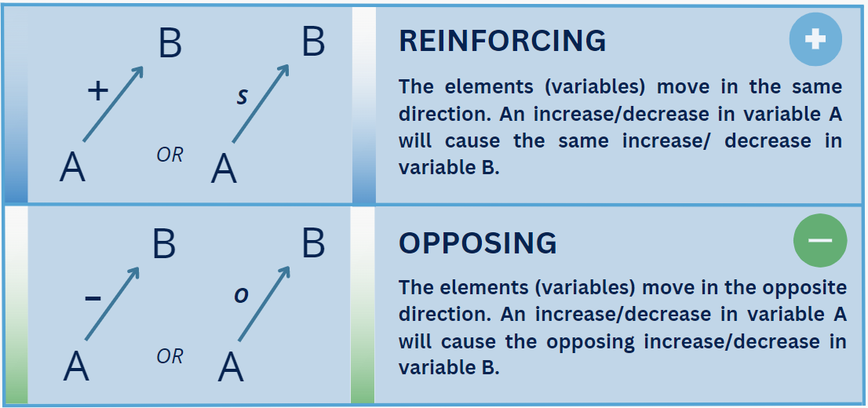

Figure 20: Polarity signs in Causal Loop Diagrams redrawn from Lane (2008). An ‘s’ and an ‘o’ are also used to symbolise the type of relationship.

When there are multiple connections between elements, they can form causal or feedback loops. A feedback loop is a closed sequence of causes and effects, that is, a closed path of action and information (Richardson and Pugh, 1981). Causal loops are either reinforcing (vicious or virtuous circles) or balancing, where self-correction occurs within the system. Every causal loop should tell a story that links cause and effect through feedback:

* Reinforcing — engine for the growth or decline of a system.
* Balancing — a steady state of a system.

#### System Scales and Levels

A system is manifested in scales and levels which importantly place the system-in-focus and our representation of it in CLDs in time and space, i.e. what systems interact beneath (sub-systems) and what interact above (meta-system):

**Temporal scale and delays:** This can range from seconds to minutes or years to infinity. The temporal scale of a systems is set according to the time-feedback mechanisms in the system take (aka ‘delays’). The system behaviour can indicate the duration of feedback delays (time-lags). For example, if there is a time-lag in the impact of one variable on another of a century, then this determines the time-frame of the feedback loop. If an issue has a much shorter time-frame then we can choose to not include feedback with very long time-lags as their impacts will not be realized over the period of interest. However, it may be relevant to also develop CLD with longer time-frames to ensure that long, slow changes are not disregarded and also we must be sensitive to instances where the speed of change accelerates, such as climate change in different latitudes.

**Physical scale:** This is the spatial size of the system and is important given that the ability to affect system behaviour usually occurs over a shorter time-scale in smaller systems than larger ones; Figure 20 gives an example of the physical and temporal scales.

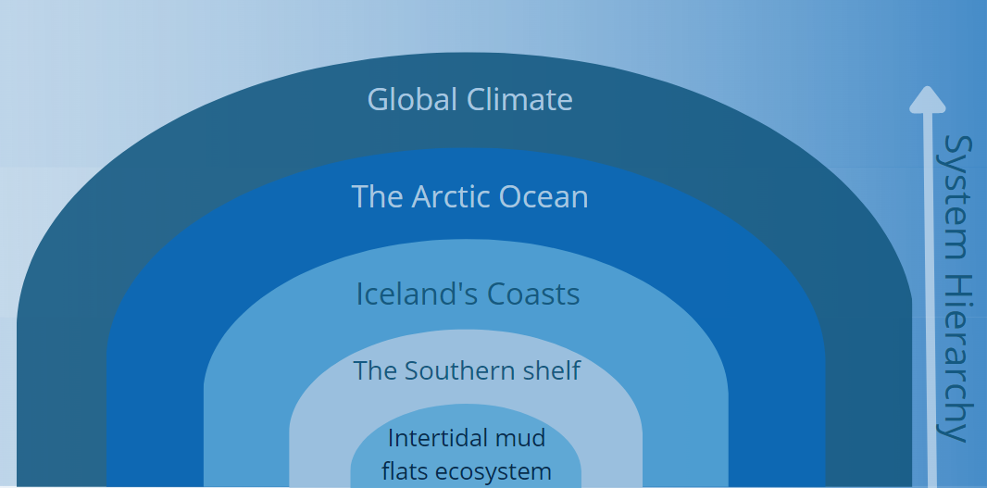

Figure 21: Example of the varying scales of a systems boundaries using an Intertidal mudflat in the southern shelf of Iceland.

**Interaction between Levels:** An issue can be manifest at many different levels so it is important to identify the level at which the Impacts of concern are being realised. On a physical scale, a single organism as a system is small and occupies a micro level compared to, for example, climate which has many system levels and occupies a large physical space at the macro level; although the two systems are different, they can interact. Climate can influence individual organisms and vice versa, but climate resides higher in the system level hierarchy which covers the several levels of biological organisation from the cell, through individuals to populations, communities and ecosystems. Models are built on systems that influence the level above them (meta-system) or below them (sub-systems). Therefore, it is necessary to identify where along the physical continuum the model is focussed, this is known as the level of abstraction.

Levels of abstraction in a causal loop diagram (CLD) refer to how broadly or specifically we represent elements within the diagram. For example, if we consider the activity of "fishing," we can either keep it as a single entity or break it down into different types like "trawling," "line fishing," and "net fishing." Higher levels of abstraction provide a broader view of the system, allowing us to observe overall trends, while lower levels of abstraction offer more detailed insights, highlighting specific trends in the system. Hence, the term "level of abstraction" indicates the degree to which behaviours influence the system. Depending on the situation, this influence can be focal (centred on a specific element), spatial (affecting a particular area), or temporal (impacting a specific time period). It is of note that in seeking to portray complex systems in simple ways, detailed knowledge of the underlying sub-systems and elements may not just be unnecessarily but actually counter-productive in inhibiting our ability to ‘see’ underlying structures hence such lower level systems may be regarded as ‘black boxes’ particularly which may also assist with maintaining a consistent level of understanding. In such black boxes, the inputs into and outputs from the black box may be known even if the black box internal functioning is unknown (Odum, 1971).

This guide integrates the DAPSI(W)R(M) and CLD analyses to increase the understanding of how the focal issue creates multiple affects, identified by creating impact-based CLDs, and also a composite CLD for the issue overall. Simple CLDs are often hand-drawn but the large and interlinking number of elements and connections may be difficult to represent on a hand-drawn model; hence, there are several data visualisation software packages that are available to support the building of CLDs. Some software packages (e.g. Vensim, iThink) provide additional model building features that mean that stock and flow and system dynamics models, which give enhanced analysis and simulation capability, can be built from CLDs, whereas other software packages (e.g. Kumu, Gephi) are more focussed on network analysis and associated tools of analysis. After considering these different tools, this guide has adopted integrating DAPSI(W)R(M) analysis with CLDs using Kumu software as Excel spreadsheets; the latter allows prior data from an analysis software program to be easily integrated.

### Causal Loop Diagramming in Kumu

Kumu is available at [https://Kumu.io](https://kumu.io) and an overview of the software is provided at [https://Kumu.io/tour](https://kumu.io/tour). Kumu is free to join and public projects can be created for free. If projects need to be kept private then it is necessary to pay for Pro Workspaces. See the Kumu pricing variants at [https://Kumu.io/pricing](https://kumu.io/pricing). Once you have joined Kumu, various introductory materials are provided to get you started and familiarised with the software ([https://docs.Kumu.io/getting-started/readme](https://docs.kumu.io/getting-started/readme)). We recommend that you watch the videos:

* ‘5 minute quickstart’ ([https://docs.Kumu.io/getting-started/readme#five-minute-quickstart](https://docs.kumu.io/getting-started/readme#five-minute-quickstart))
* ‘Kumu 101’ ([https://docs.Kumu.io/getting-started/Kumu-101](https://docs.kumu.io/getting-started/kumu-101))
* Then having a go at creating a causal loop diagram in your own sandbox ([https://docs.Kumu.io/getting-started/first-steps](https://docs.kumu.io/getting-started/first-steps)).

Various templates are available in Kumu to automate aspects of the visualisation process and for the purposes of the DA project it is recommended that you select the causal loop template. Although all members of the group should familiarise themselves with the process of causal loop diagramming and the format of such diagrams in Kumu, we suggest that one member of the group takes responsibility for creating and updating the CLDs in Kumu. This, together with identifying who is responsible for updating the Excel spreadsheets, requires building into your Resource Management plan.

### Dynamic Complexity and Behaviour Over Time (BOT)

BOT graphs (also called ‘reference modes’) show the pattern of behaviour of elements over an extended period of time e.g. a reinforcing loop may show a BOT of a virtuous or vicious nature as the growth or decline of something may have positive or negative consequences depending on the context. In BOT graphs, the horizontal axis represents time and the vertical axis represents the performance measure of interest. The important parts of BOTs are the overall directions and variations, not the value of the element. Therefore, BOTs usually give approximate indications rather than the exact value of the element. The behaviour of several elements can be shown in the same BOT graph.

Whilst the DAPSI(W)R(M) is useful for issue structuring, it may focus on identifying data gaps, but this requires further interrogation to fill those data gaps or understand their importance which may be constrained by the readily-available data. BOT graphs may overcome the data availability problem by building causal theories prior to data gathering. The BOTs can be used to connect past observed behaviour with future behaviour to help understand the underlying causal structures and, by developing our understanding of potential system behaviours, guide data acquisition for building or testing theories.

BOT graphs can be used to identify which types of system processes are occurring. For example, a rapidly increasing or decreasing behaviour over time graph indicates that reinforcing loops are influencing the system (see Figures A and B in Figure 26). In contrast, an oscillating behaviour over time would indicate that balancing feedback mechanisms are occurring in the system (see Figure C Figure 26).

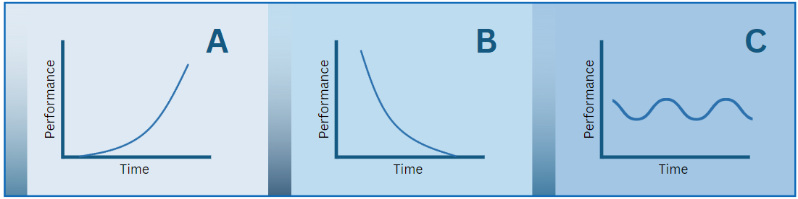

Figure 26. Behaviour over time Graphs – A and B represent reinforcing feedback loops, and C represents a balancing feedback loop; redrawn from Mclean, et al (2019).

In summary, the behaviour of elements key to the issue of concern are plotted in a BOT graph and a theory of causal behaviour is presented; data are then located to either prove or disprove the theory. Through an iterative process between theory-building and data analysis, we can build a better understanding of what is happening; further information is given in: [https://thesystemsthinker.com/behaviour-over-time-diagrams-seeing-dynamic-interrelationships/](https://thesystemsthinker.com/behavior-over-time-diagrams-seeing-dynamic-interrelationships/).

### Summary of the recommended DAPSI(W)R(M)/CLD modelling process:

Below is a summary of the modelling process, the colours indicate the three phases of the ISA analysis; Red = Setting priorities, Yellow = Getting the information, Green = Using the information.

1. In the Marine SABRES project, the focus issue for each DA has been defined by stakeholder engagement in WP2. In future use, upon upscaling, the initial stage will include a process of issue identification using, for example, rich pictures.
2. Associated with the focal issue are a number of Impacts on human Well-being and it may be that we need to prioritise these by, for example, using the Delphi approach. In each DA or component part of a DA in MarineSABRES, the aim is to create a CLD for each of the priority Impacts together with a composite CLD of the Impacts that are focussed on the Issue and over a relevant time-horizon. The creation of one or more CLDs aims to increase our understanding regarding the behaviour of the system that is causing concern.
3. Taking each Impact in turn, identify the relevant indicator to measure the variable and record a time-horizon over which the effects on societal goods/benefits are manifest.
4. Repeating step three for the relevant DAPSI(W)R(M) framework elements, to examine and explain the Impact of concern. Using the DAPSI(W)R(M) framework in this way should help bound your CLD in terms of what is deemed relevant to include and also help you achieve a consistent level of understanding.
5. Define the Impact dynamically by reviewing historical data on key elements and drawing Behaviour-Over-Time charts for them. These charts can serve as reference points throughout the theory-building process, helping focus the conceptualization, and validate emerging theory.
6. Identify and label loops and identify key leverage points.
7. Explore the behaviour of the system by tracing out the loops and main issues (stories): start with a variable that is critical to the focal question and then trace out the loops that affect it. You can also conduct thought-experiments by hypothesizing about the behaviour over time of different elements and inferring the behaviour of other related elements. Do ‘what-if' experiments of possible future scenarios and draw out the implications of those events on other elements.
8. Use your CLDs to build causal theories that draw out the interrelated behaviour of elements over time.
9. Access and analyse relevant data to help validate the BOTs, causal connections, and causal theories derived from your CLD.
10. Once you are satisfied that you have sufficiently developed, explored and validated each Impact based CLD, add it to your composite Issue-based CLD. Explore how this addition adds to your understanding of the system behaviour regarding the focal issue of concern. As with the Impact-based CLDs, explore the systems behaviour through tracing out the loops, storytelling, identification of leverage points and ‘what if’ analysis.

In bringing together the DAPSIW)R(M) model, systems thinking in the form of causal loop diagramming and other approaches, and a system for good project and information management, the Integrated Systems Analysis therefore represents a significant shift in our thinking about how we tackle complexity in the marine environment on an ongoing basis as an action learning cycle (see Figure 22).

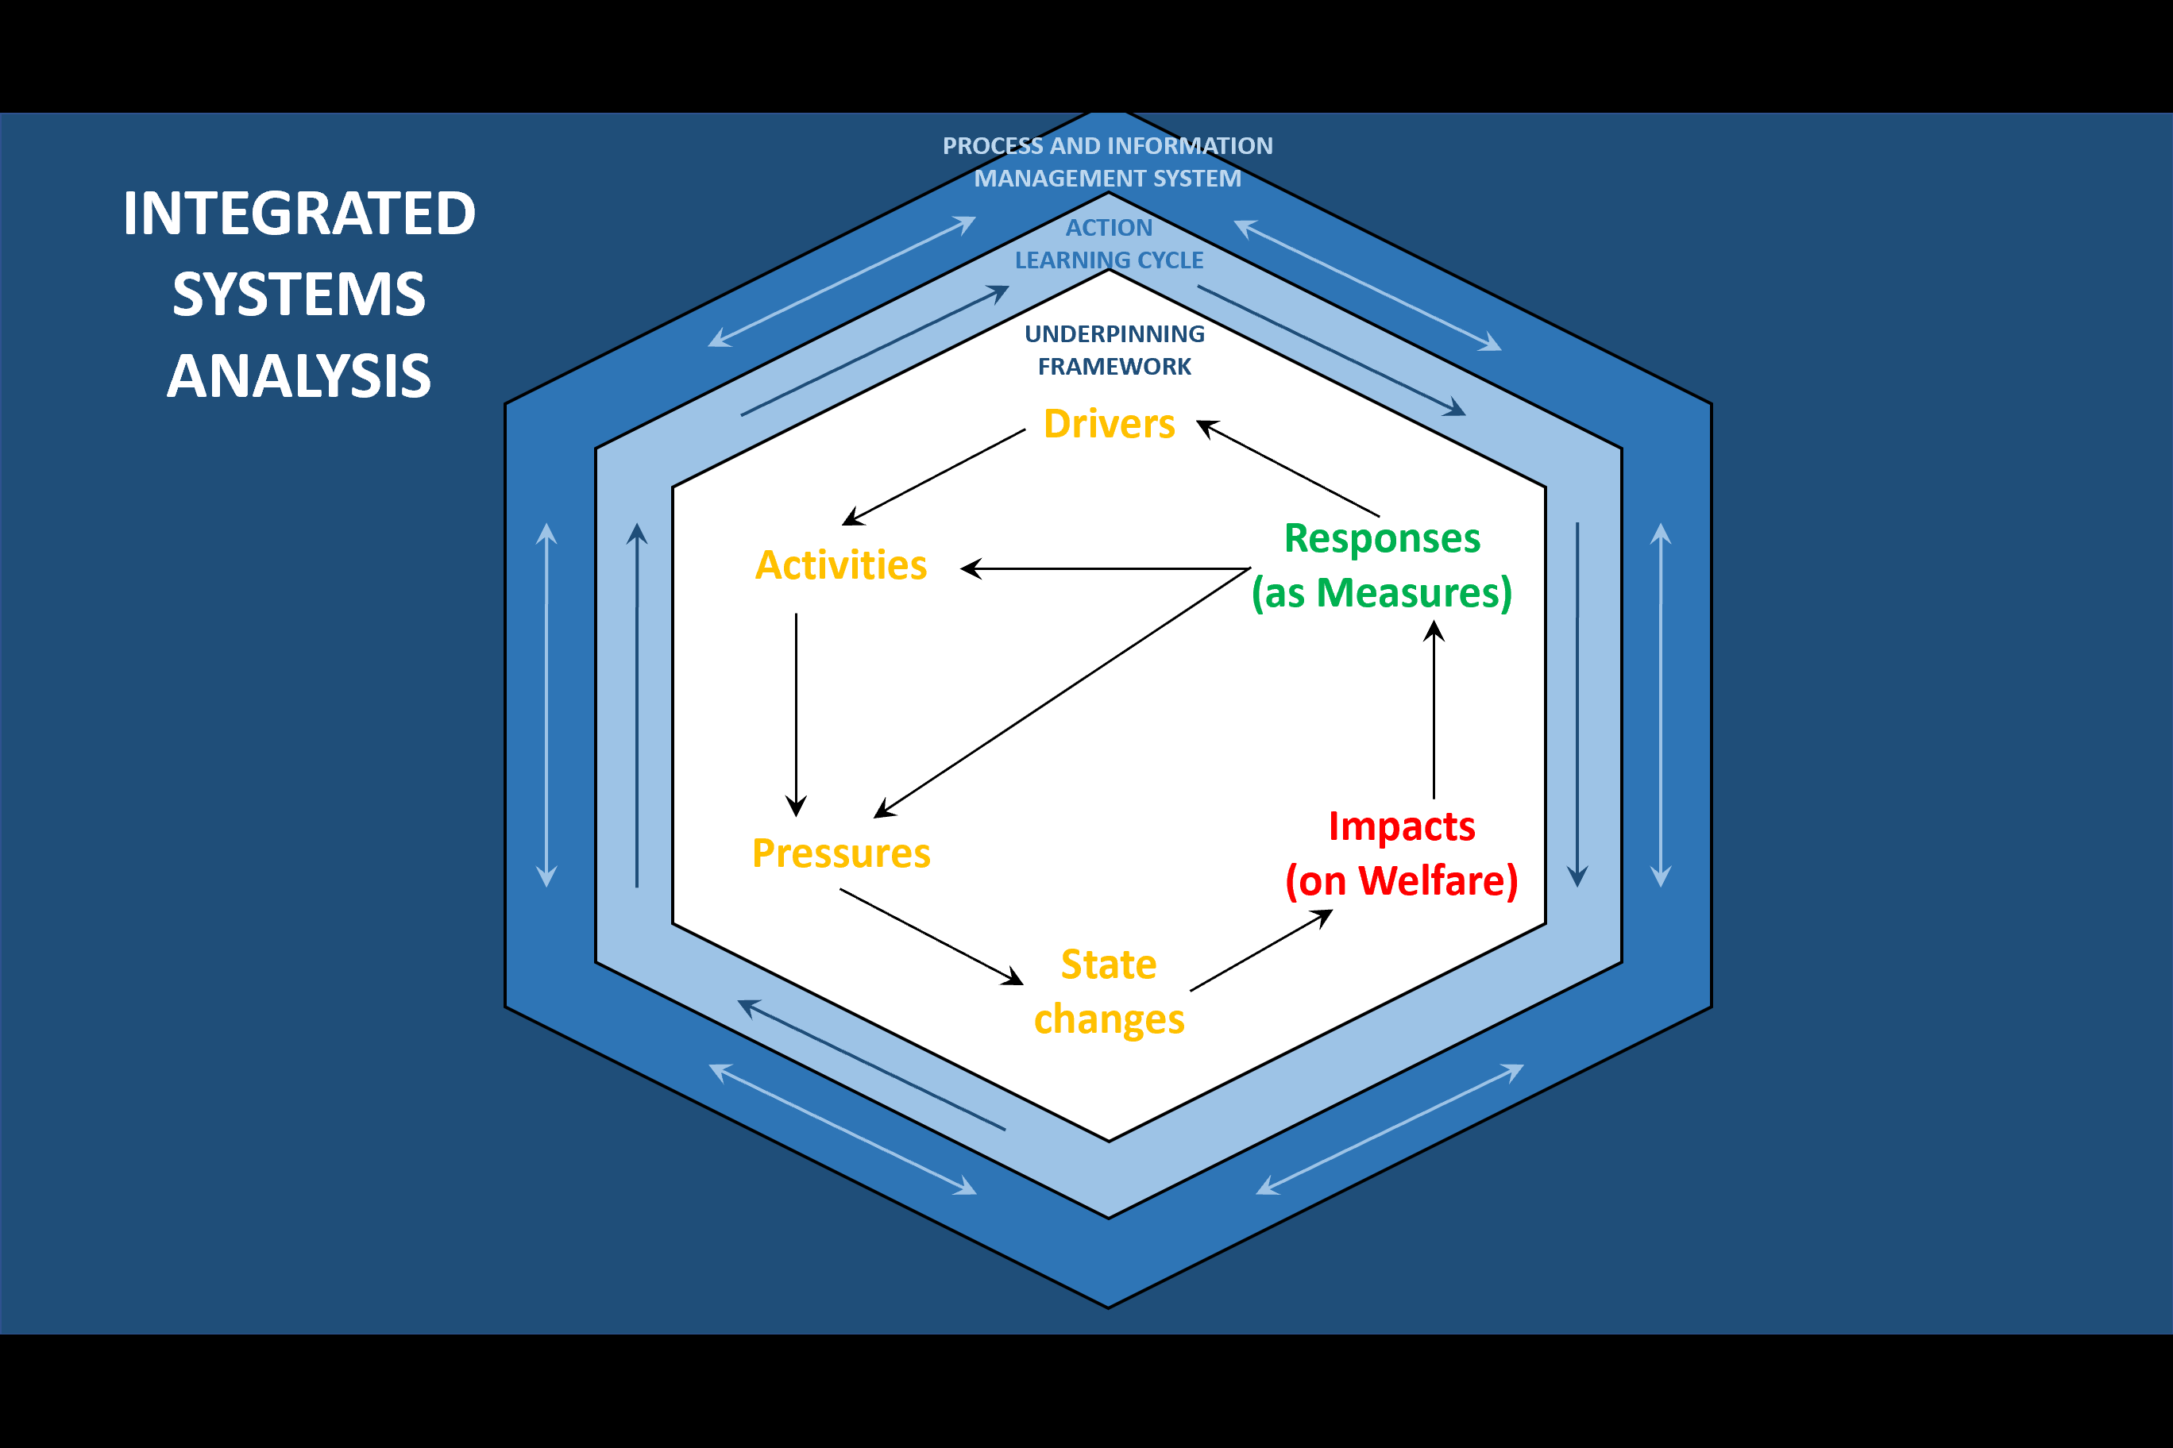

Figure 22: The Action Learning Cycle of Integrated Systems Analysis.

## Part III: The Simple SES Analysis

In this section of the guide, the steps that are involved in undertaking an Integrated Systems Analysis are detailed. You will need the corresponding ISA Excel workbook to organise and store your data.

### Preliminary Exercise 0: Unfolding Complexity and Impacts on Welfare

This initial exercise sets the scope for the impacts on welfare as the result of the identified marine problems and focal issues of concern. As the latter have already been defined by stakeholders for each of the DAs in the Marine SABRES project document and by the mind-mapping exercise in WP2, the first task is to consider the questions in Table 5:

Table 5: Table containing key considerations of setting the scope of the analysis.

|  |  |
| --- | --- |
| **Question to consider** | **Comments:** |
| What are the impacts within the social system of the focal issue on human welfare and over what time-frame? |  |
| At what spatial scale (individual, regional, national or international) do the impacts of the most pertinent issues occur? |  |

In systems thinking, there are usually three levels of consideration: the metasystem, the system in focus (or focal level), and sub-systems. It's like looking at the ocean environment from different vantage points.

* Metasystem: This is the highest, broadest level, like looking at the entire ocean environment as a whole, including all seas, marine life, climate influences, and human activities.
* System in Focus: This is the spatial area to be studied. It's more detailed than the metasystem but not as narrow as a sub-system. For instance, your system in focus could be the North Sea and all its related elements.
* Sub-systems: These are smaller, specific areas within the system in focus. For example, within the North Sea, a sub-system could be the ecosystem of a specific coral reef or the fishing industry in a specific region.

It's crucial to identify which level you're focusing on and why, to ensure consistency in your analysis and recommendations. Remember, suggestions relevant to one level might not apply to another.

Once you've defined your system of focus – for example, the impact of commercial fishing on the North Sea ecosystem, next identify the impacts this has on human welfare, such as economic benefits, job creation, and food provision. Maintaining a clear focus on the system in focus while also considering its role in the broader system and its various sub-components can help identify different levels of management actions and ensure consistency in the approach. Having clarified the focal issue/spatial system of interest and the impacts on human welfare, the next step orders these in terms of importance or priority. Starting with the impact of most importance, this guidance works through the DAPSI(W)R(M) cycle of analysis to create a causal loop diagram for this impact.

**Causal Loop Diagram scoping:**

When developing CLDs, a key to success is to find the appropriate level of detail that addresses the questions posed. When defining the scope of the CLD, there are three elements that need to be considered (Kim, 2000):

* The timeframe of interest – over what period of time did impact of interest unfold? Do actions and outcomes that occur on a daily, weekly, monthly or yearly basis need to be captured?
* The boundary (footprint) of the impact - where do we draw the line for what should be included in the diagram and what is regarded as external to it (respectively endogenic and exogenic features)?
* The level of system aggregation - what is the level of aggregation in the CLD or level of detail needed to understand patterns of behaviour across the different Drivers, Activities, Pressures, State changes and Impacts on Welfare? Will the focus be on capturing community regional, national or global dynamics?

It is of note that, when determining the scope of a CLD, the goal should always be to use CLDs to map key structural drivers for the issue of interest, not to try and map the feedback that drives behaviour in the entire, wider system (Sterman, 2000a). This is key to avoiding overly complex diagrams which may obscure key dynamics around the focal issue of interest. For further information on CLD Scoping see: <https://academic.oup.com/heapol/article/37/10/1328/6654776>

### Exercise 1: Specifying Goods and Benefits Related to the Impact on Welfare

1. Referring to the goods and benefits in the Excel drop down list and referring to BP6: *Indicators,* identify goods and benefits related to the issue of concern (Figure 23).
2. Using the drop-down list in (Column B) of the Master sheet, select the top five priority goods and benefits relating to the impact of concern.
3. Using the drop-down list (Column C) Identify indicators (quantity/quality) for each good/benefit (physical and/or monetary units).

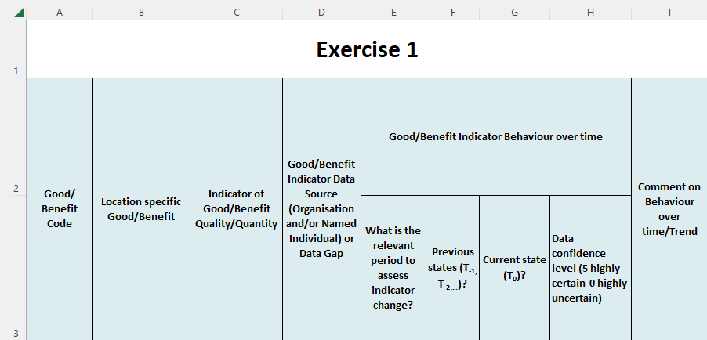

Figure 23: Screen Clip of the Exercise 1 columns to complete.

1. Identify data sources to populate the indicators, assess behaviour over time and stakeholders who may be able to provide these data (Column D).
2. Assess changes (trends) over time.What is a meaningful period of time to work across?(Columns E) and what data are available on previous states (Columns F and G) and the current state (Column H).
3. Use the Goods and Benefits Behaviour Over Time Graph link on the home Sheet to fill in the Sheet for data of the indicators (Figure 24).

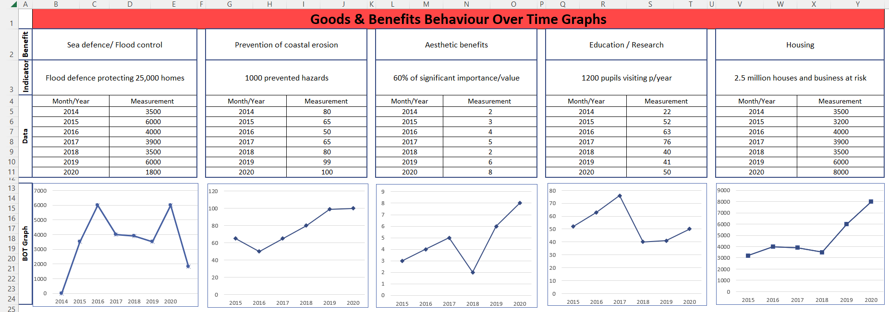

Figure 24: Screen clip of Behaviour Over Time Graphs sheet for the Goods and Benefits indicators.

### Exercise 2: Specifying State Changes (Marine Ecosystem Processes and Functioning and Ecosystem Services) that affect Impacts on Welfare (Goods and Benefits)

State changes which affect the Impacts on Welfare (Goods and Benefits) are separated into Ecosystem services and Marine Processes and Functioning. Marine processes and functioning give rise to ecosystem services (provisioning and regulating services) which provide society with goods and benefits. Hence, this exercise details the logical chain of the impacts that ecosystem services have on goods and benefits (Exercise 2(a)). Followed by the relationship between ecosystem services and the marine functioning and processes (Exercise 2(b)).

#### Exercise 2 (a) For Ecosystem services:

1. For each good/benefit (Column B), with reference to BP6: *Indicators*, and using the dropdown list (Column L), specify the ecosystem service(s) that affect it (Figure 25).
2. 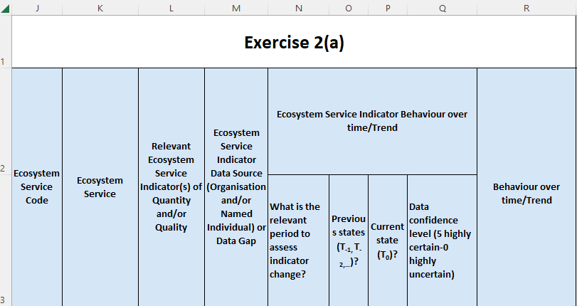Using the dropdown list (Column M), identify indicators for each ecosystem service (multiple indicators are possible – specify ecosystem service indicators in physical units only but not monetary units).

Figure 25: Screen Clip of Exercise 2(a) master sheet columns to complete.

1. Identify data sources to populate the indicators, assess behaviour over time and stakeholders who may be able to provide these data (Column N).
2. Assess changes (trends) over time.What is a meaningful period of time to work across?(Column N) and what data are available on previous states (Column O) and the current state (Column P).
3. Use the Ecosystem Services Behaviour Over Time Graph link on the home page to fill in the Sheet for data of the indicators (Figure 26).

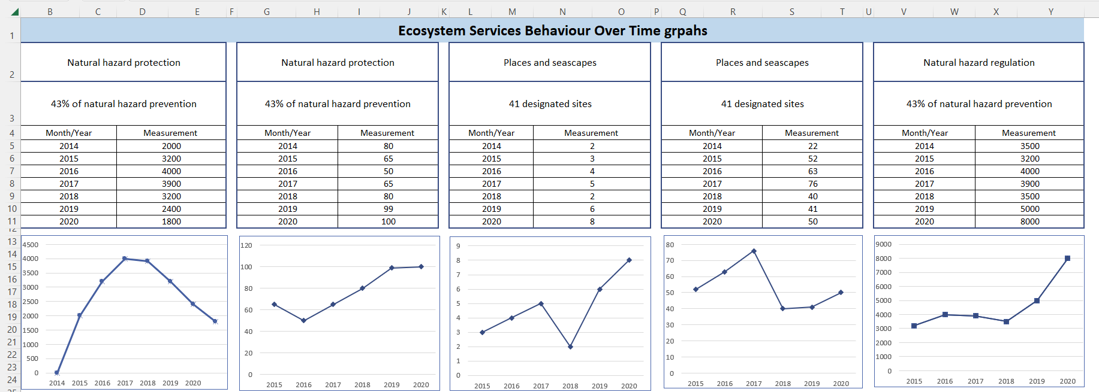

Figure 26: Screen clip of Behaviour Over Time Graphs sheet for the Ecosystem Services indicators.

1. Next we assess the relationship between ecosystem services and goods and benefits by clicking the ‘Adjacency matrix for GB &ES’ on the home Sheet (Figure 27).
2. Referring to the indicators BOT, use the drop-down cells in both adjacency matrices (Adjacency matrix and sensitivity matrix) to assign whether two variables have a ‘+’ (giving to) or ‘–‘ (taking away) connection and if this is strong, medium or weak positive or negative.

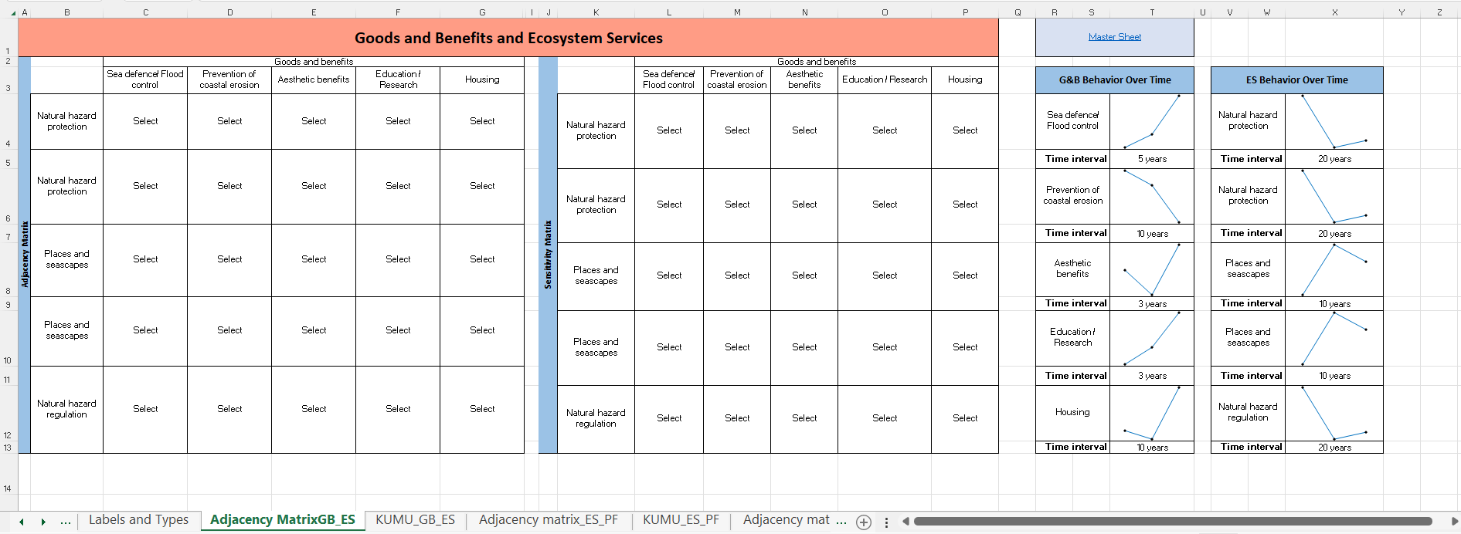NOTE: The matrix plots out the relationships between ecosystem services and goods/benefits on the causal loop diagram. Where possible, justify the strength of the relationship, as this information will be required to inform understanding of the model when it comes to evaluating response options.

Figure 27: Screen Clip of the Adjacency Matrix Excel sheet relating to Goods and Benefits and Ecosystem Services to complete. Cells worded ‘select’ contain the dropdown list, the rest of the matrix cells will be auto-populated from the master sheet.

1. Export the KUMU sheet called ‘KUMU Goods and Benefits and Ecosystem Services’ to a .csv file. Go to Kumu and press the green + to upload.

#### Exercise 2(b) for Marine Ecosystem Processes and Functioning:

1. For ecosystem service(s) (Column L), with reference to BP6: *Indicators,* and using the dropdown list (Column U), specify the marine processes and functioning that affect it/them (Figure 28).
2. 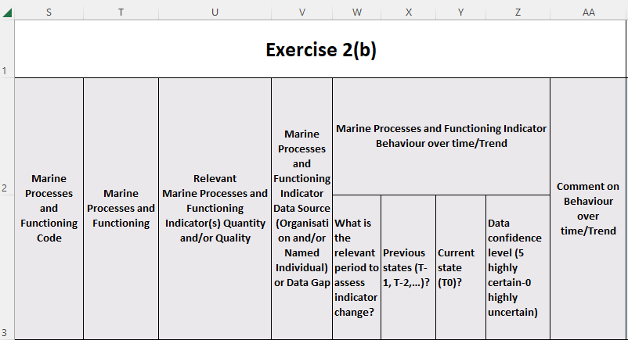Using the dropdown list (Column U), identify indicators for each marine process and function (multiple indicators are possible – specify ecosystem service indicators in physical units only but not monetary units)

Figure 28: Screen clip of Exercise 2(b) master sheet columns to complete.

1. Identify data sources to populate the indicators, assess behaviour over time and stakeholders who may be able to provide these data (Column V).
2. Assess changes (trends) over time.What is a meaningful period of time to work across?(Column W) and what data are available on previous states (Column X) and the current state (Column Y).
3. Use the Marine Processes and Functioning Behaviour Over Time Graph link on the home page to fill in the Sheet for data of the indicators (Figure 29).

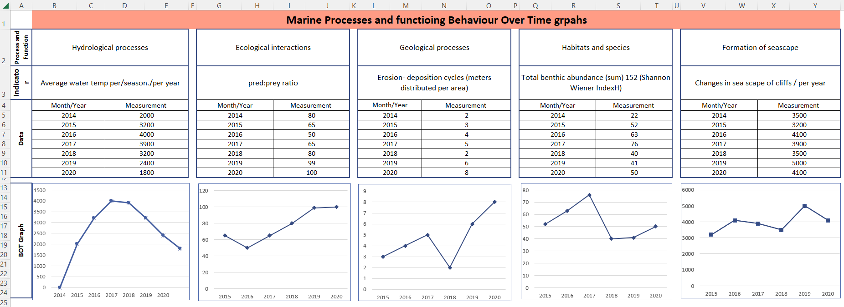

Figure 29: Screen clip of Behaviour Over Time Graphs sheet for the Marine Processes and Functioning indicators.

1. Next we assess the relationship between Marine Processes and Functioning and Ecosystem Services by clicking the ‘Adjacency matrix and BOT for Ecosystem Services and Marine Processes and Functioning link on the Home Sheet (Figure 30).
2. Referring to the indicators BOT, use the dropdown cells in the both adjacency matrices (Adjacency matrix and sensitivity matrix) to assign if two variables have a + (giving to) or – (taking away) connection and if this is a strong, medium or weak positive or negative.

NOTE: The matrix plots out the relationships between Marine Processes and Functioning and Ecosystem Services on the causal loop diagram. It is recommended to provide a justification of the strength of relationship, as this information will be required to inform understanding of the model when it comes to evaluating response options.

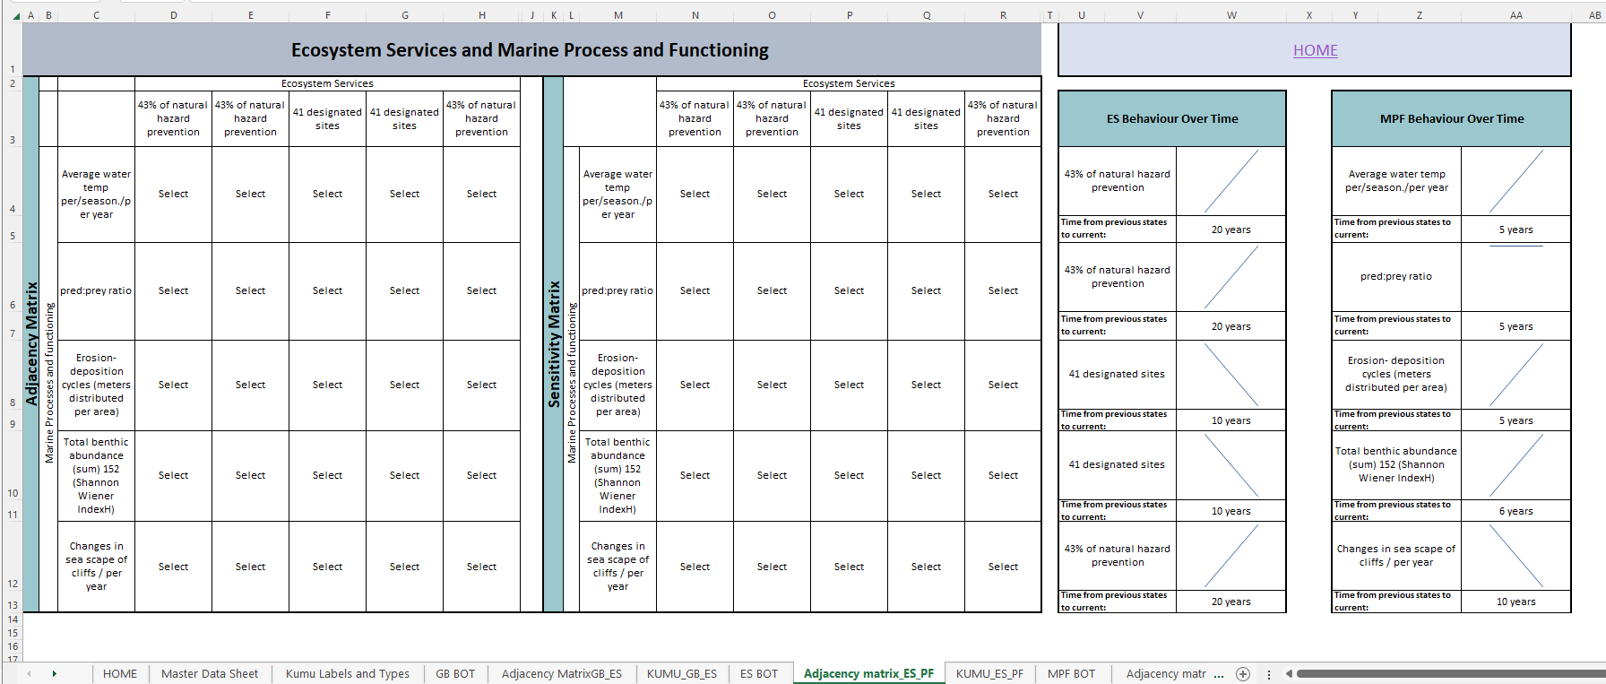

Figure 30: Screen Clip of the Adjacency Matrix Excel sheet relating to Ecosystem Services and Marine Processes and Functioning to complete. Cells worded ‘select’ contain the dropdown list, the remaining cells will be auto-populated from the master sheet.

1. Export the KUMU sheet called ‘KUMU Ecosystem Services and Marine Processes and Functioning’ to a .csv file. Go to Kumu and press the green + to upload.

### Exercise 3: Specifying Pressures on State Changes (Marine Ecosystem Processes and Functioning and Ecosystem Services)

1. For Marine Processes and Functioning (Column AC), with reference to BP6: *Indicators,* and using the dropdown list (Column AC), specify the Pressures that affect its delivery or provision (Figure 30).
2. Using the dropdown list (Column AD), identify indicators for each marine process and function.
3. Categorise each pressure as local, regional, national or international (Column AF).

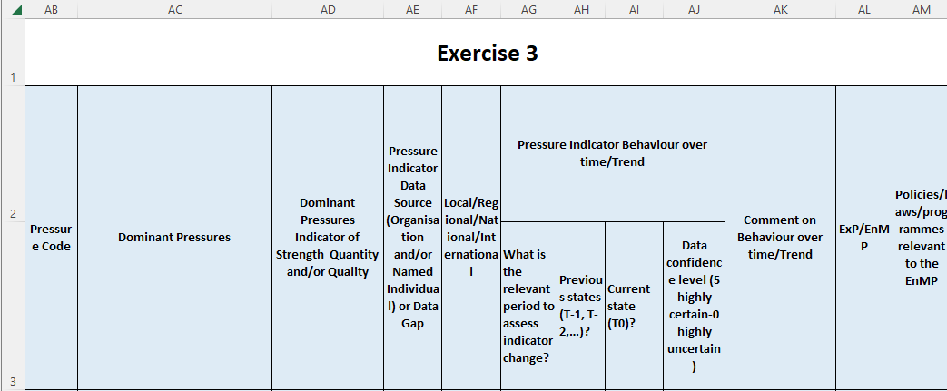

Figure 31: Screen clip of Exercise 3 master sheet columns to complete.

1. Identify data sources to populate the indicators, assess behaviour over time and stakeholders who may be able to provide these data (Column AD).
2. Assess changes (trends) over time.What is a meaningful period of time to work across?(Column AG) and what data are available on previous states (Column AH) and the current state (Column AI).
3. Use the Pressures Behaviour Over Time Graph link on the home page to fill in the Sheet for data of the indicators (Figure 32).

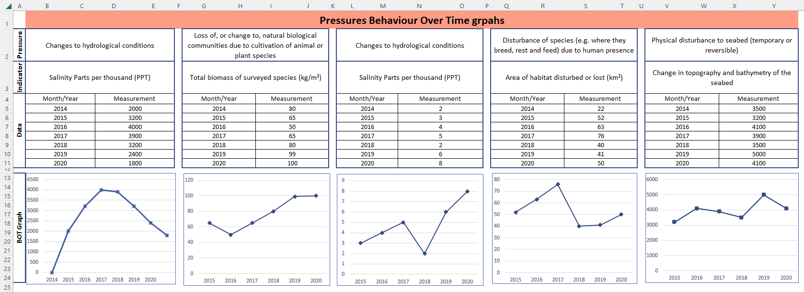

Figure 32: Screen clip of Behaviour Over Time Graphs sheet for the Marine Processes and Functioning indicators.

1. Categorise each pressure as either an exogenic pressure (ExP) or an endogenic managed pressure (EnMP) (Column AL).
2. Identify policies, laws and programmes relevant to the management of the endogenic managed pressures (Column AM).
3. Next we assess the relationship between Pressures and Marine Processes and Functioning by clicking the ‘Adjacency matrix for Marine Processes and Functioning and Pressures’ on the home Sheet.
4. Referring to the indicators BOT, use the dropdown cells in the both adjacency matrices (Adjacency matrix and sensitivity matrix) to assign if two variables have a + (giving to) or – (taking away) connection and if this is a strong, medium or weak positive or negative (*Figure 33)*.

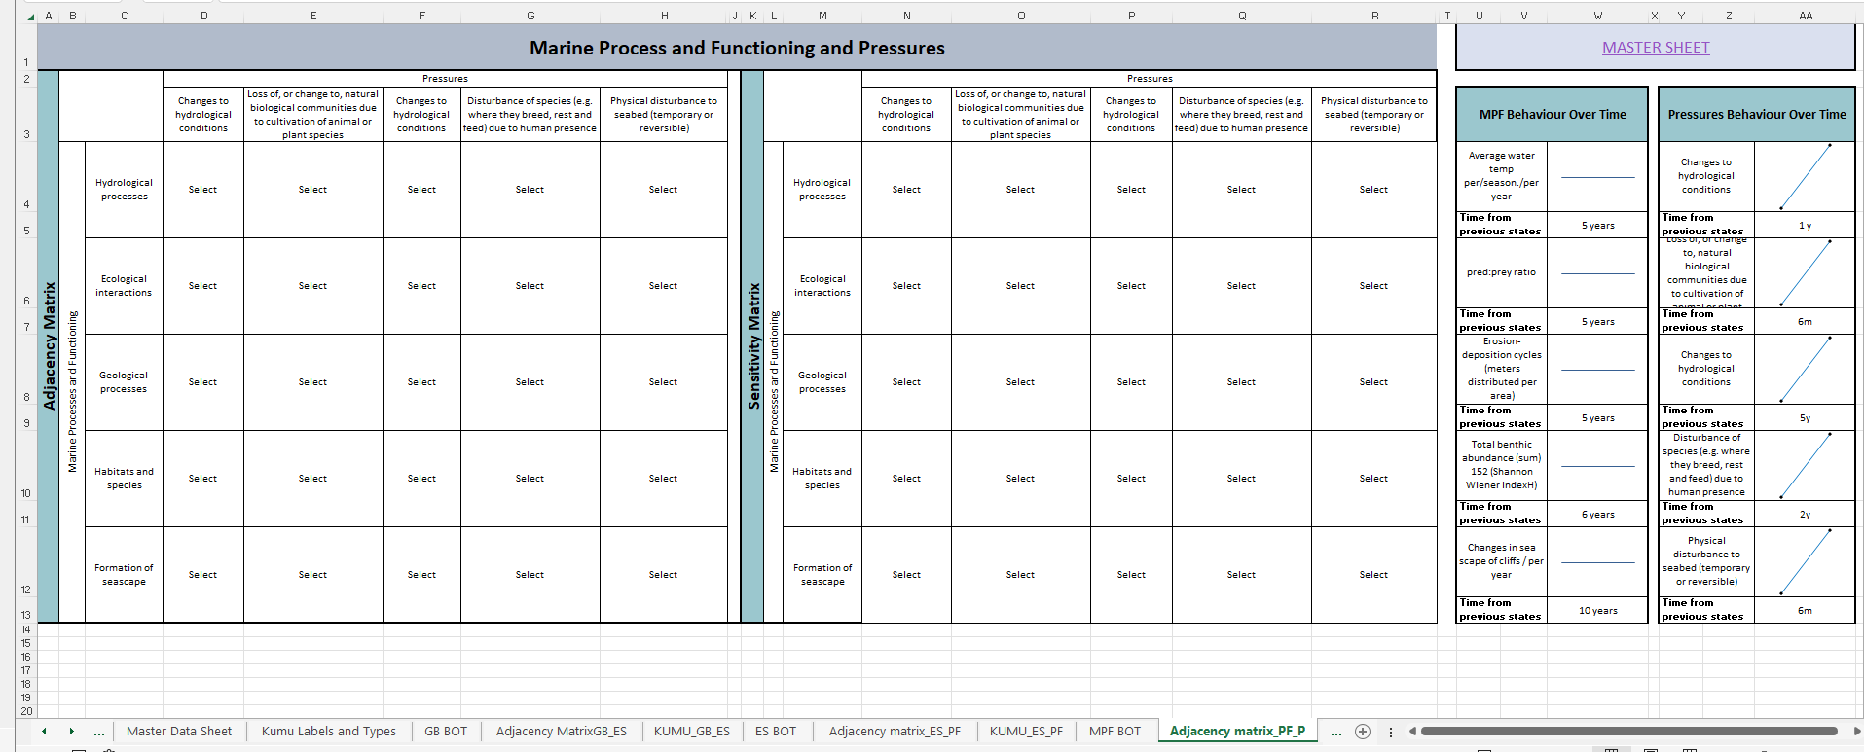

Figure 33: Screen Clip of the Adjacency Matrix Excel sheet to complete in relation to Marine processes and Functioning and Pressures. Cells worded ‘select’ contain the dropdown list, the rest of the cells will be auto-populated from the master sheet.

1. Export the KUMU sheet called ‘KUMU Marine Processes and Functioning and Pressures’ to a .csv file. Go to Kumu and press the green + to upload.

### Exercise 4: Specifying Activities that Affect Pressures

1. For each pressure (Column AC), with reference to BP6: *Indicators,* specify the individual, group/sector, national and/or international economic and social activities that give rise to that pressure (Column AO) (Figure 34).
2. Specify if the Activity is carried out by an individual, group/sector, national and/or international economic and social entity using the dropdown list in Column AR.
3. Using the dropdown list (Column AS), identify indicators for each marine process and function (multiple indicators are possible – specify ecosystem service indicators in physical units only but not monetary units).

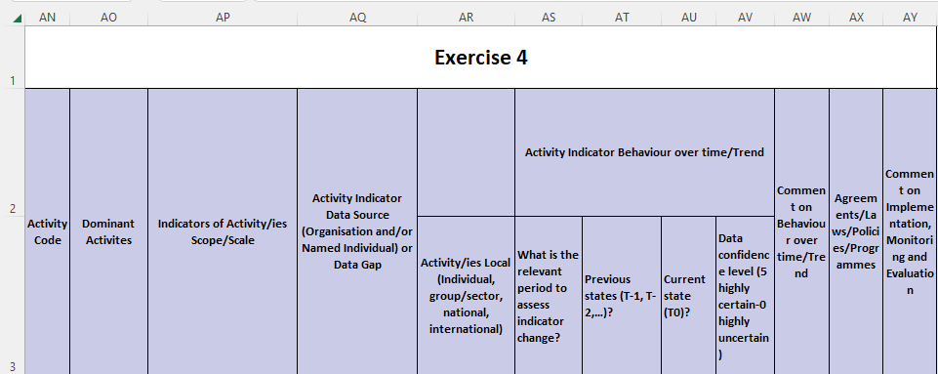

Figure 34: Screen Clip of the Exercise 4 columns to complete.

1. Identify data sources to populate the indicators, assess behaviour over time and stakeholders who may be able to provide these data (Column AQ).
2. Assess changes (trends) over time.What is a meaningful period of time to work across?(Column AS) and what data are available on previous states (Column AT) and the current state (Column AU).
3. Use the Activities Behaviour Over Time Graph link on the home page to fill in the Sheet for data of the indicators (Figure 35).

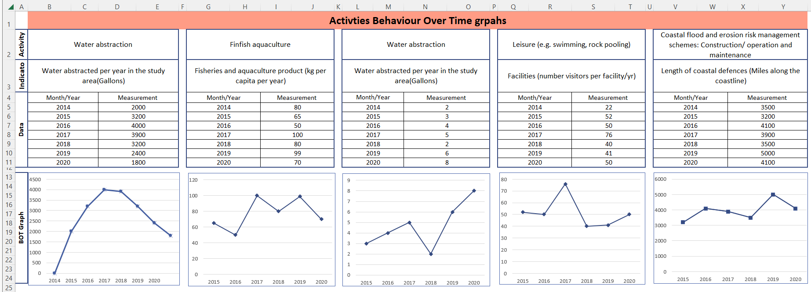

Figure 35: Screen clip of Behaviour Over Time Graphs sheet for the Activity/ies indicators.

1. Next we assess the relationship between Marine Processes and Functioning and Ecosystem Services by clicking the ‘Adjacency matrix for Ecosystem Services and Marine Processes and Functioning on the Home Sheet (Figure 36).
2. Referring to the indicators BOT, use the dropdown cells in the both adjacency matrices (Adjacency matrix and sensitivity matrix) to assign if two variables have a + (giving to) or – (taking away) connection and if this is a strong, medium or weak positive or negative.
3. Identify policies, laws and programmes relevant to the management of the activities (Column AK) and comment on how well they are implemented, monitored and evaluated (Column AV).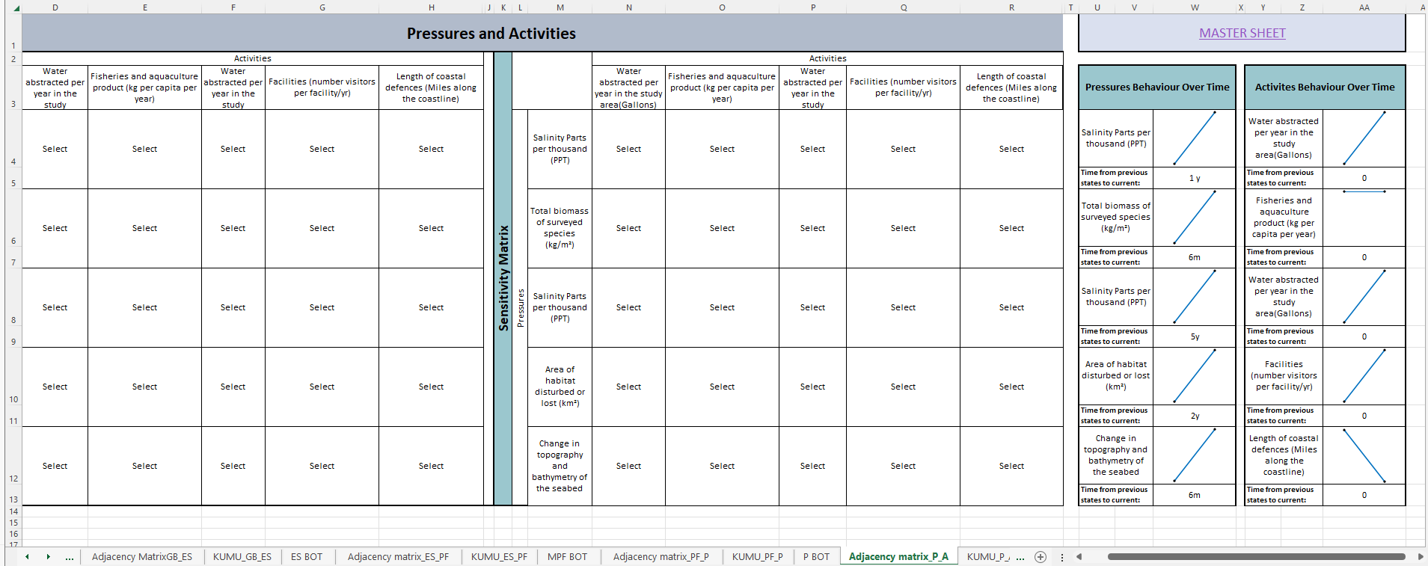

Figure 36: Screen Clip of the Adjacency Matrix Excel sheet relating to Pressures and Activities to complete. Cells worded ‘select’ contain the dropdown list, the rest of the cells will be auto-populated from the master sheet.

1. Export the KUMU sheet called ‘KUMU Pressures and Activities’ to a .csv file. Go to Kumu and press the green + to upload.

### Exercise 5: Specifying Drivers that give rise to Activities

1. For each activity (Columns AO-AR), with reference to BP6: *Indicators*, specify the human needs that each activity is aimed at satisfying (Column BC)? Is there anything else that is driving activities at different levels (individual, group, regional, national and international)? (Figure 37)
2. Using the dropdown list (Column BD), Identify indicators for the strength of needs (Column AL) and any current ecological, economic and social trends affecting it (Column AD).

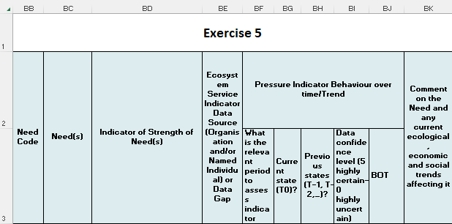

Figure 37: Screen Clip of the Exercise 5 columns to complete.

1. Identify data sources to populate the indicators, assess behaviour over time and stakeholders who may be able to provide these data (Column BE).
2. Assess changes (trends) over time.What is a meaningful period of time to work across?(Columns BF).
3. Use the Drivers Behaviour Over Time Graph link on the home page to fill in the Sheet for data of the indicators (Figure 38).
4. Comment on any current ecological, economic and social trends affecting each need identified (Column BK).

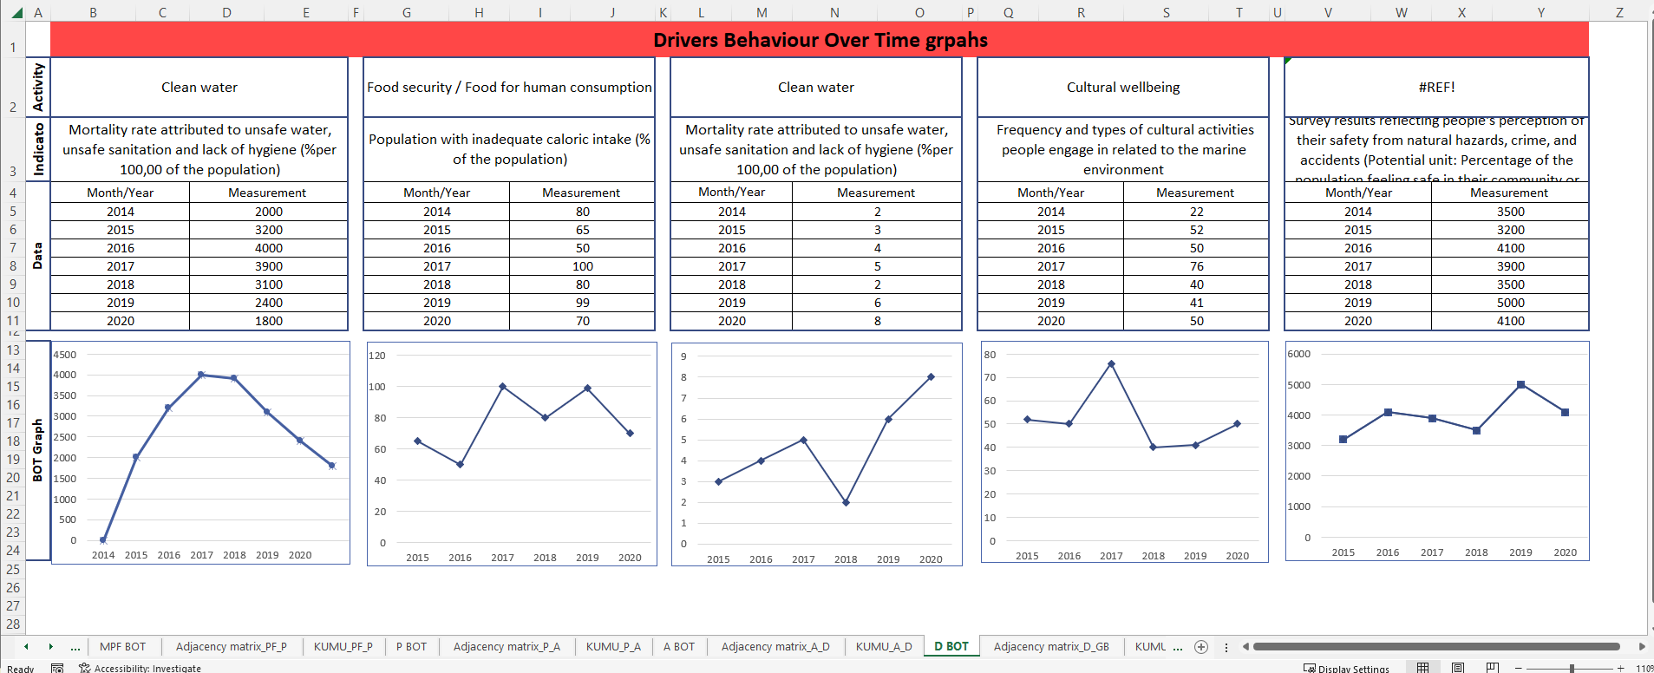

Figure 38: Screen clip of Behaviour Over Time Graphs sheet for the Driver indicators.

1. Next we assess the relationship between Activities and Drivers by clicking the ‘Adjacency matrix Activities and Drivers’ on the home page (Figure 39).
2. Referring to the indicators BOT, use the dropdown cells in the both adjacency matrices (Adjacency matrix and sensitivity matrix) to assign whether two variables have a + (giving to) or – (taking away) connection and if this is a strong, medium or weak positive or negative.

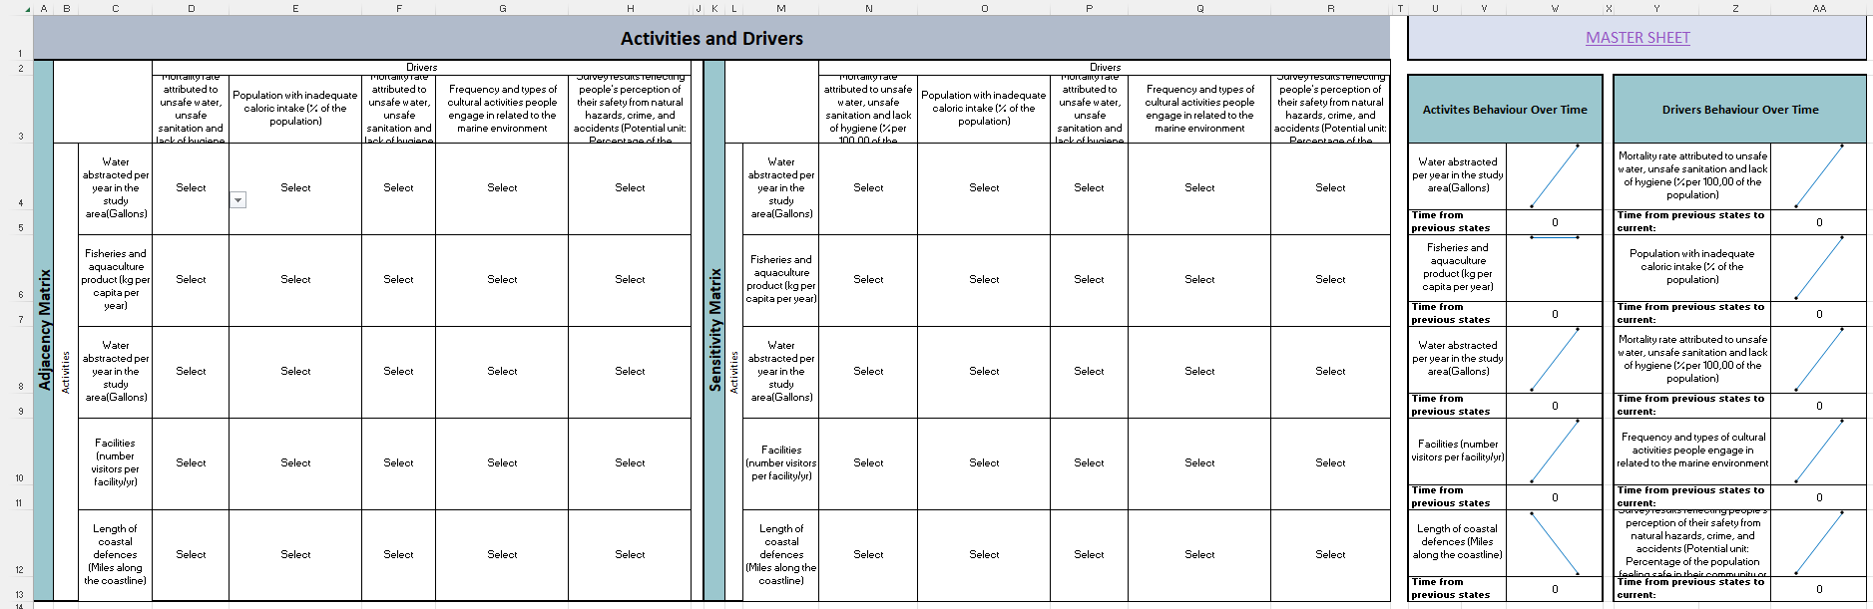

Figure 39: Screen Clip of the Adjacency Matrix Excel sheet relating to Drivers and Goods & Benefits to complete. Cells worded ‘select’ contain the dropdown list, the rest of the cells will be auto-populated from the master sheet.

1. Export the KUMU sheet called ‘KUMU Activities and Drivers’ to a .csv file. Go to Kumu and press the green + to upload.

### Exercise 6: Closing the Loop between Drivers and Impacts on Welfare (Goods/Benefits)

We can close the loop between drivers and goods/benefits by:

1. Following the ‘E6: Closing the loop’ link on the Home sheet to the Drivers and Goods & Benefits adjacency and sensitivity matrix.
2. Referring to the indicators BOT, use the dropdown cells in the both adjacency matrices (Adjacency matrix and sensitivity matrix) to assign if two variables have a + (giving to) or – (taking away) connection and if this is a strong, medium or weak positive or negative (Figure 40).

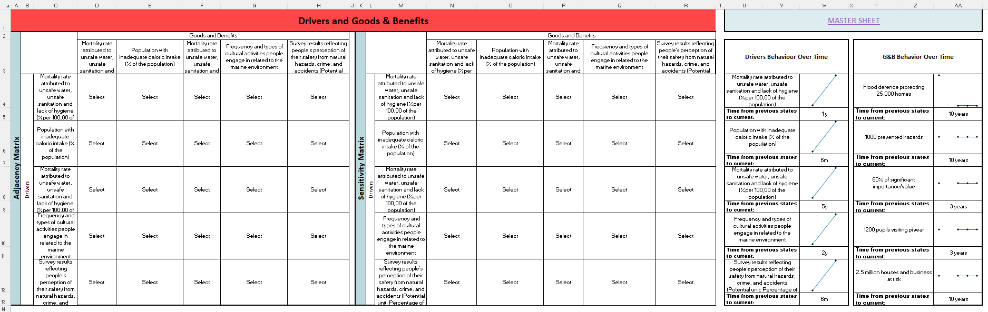

Figure 40: Screen Clip of the Adjacency Matrix Excel sheet relating to Drivers and Goods & Benefits to complete. Cells worded ‘select’ contain the dropdown list, the rest of the cells will be auto-populated from the master sheet.

1. Export the KUMU sheet called ‘KUMU Drivers and Goods and Benefits’ to a .csv file. Go to Kumu and press the green + to upload.

### Exercise 7: Creating an Impact-based CLD

#### Data availability, System and Software Requirements

The aim of the Integrated Systems Analysis is to approach the goal and/or problem to make the best-informed decision possible. Data inavailability may hinder the application of the ISA in data-poor areas. Alternate data types, such as local knowledge, expert judgement, published literature on the area or lower-resolution data, could be used in such cases to support the analysis.

Additionally, it is important to note the computational demands of software such as Kumu and a sufficiently high specification computer with be required to prevent system crashes (this is unlikely to occur on systems with i7 and i9 processors, 10th Gen and above), especially with causal loop diagrams covering many connections between elements. We recommend using the filters along the bottom of the diagram to filter out other elements to conduct a loop analysis and conduct this in smaller chunks to prevent your browser from crashing (this process is detailed within Exercised 8 and 9).

**REMEMBER:**

A PIMS Consideration referring to Data Protection (information can be found in the PIMS Excel File) - note that the use of Kumu operates in public workspaces unless private maps are purchased.

Further information on this within the Kumu software can be found here: [https://docs.Kumu.io/overview/accounts-and-workspaces](https://docs.kumu.io/overview/accounts-and-workspaces).

#### Preparing Kumu to import your adjacency matrices

1. On the ISA excel workbook go to the sheet named ‘Label and Type’ and export the worksheet to .csv file with the same name.
2. Go to [https://Kumu.io/](https://kumu.io/) and create a new project in Kumu and choose the Causal Loop template. Give the project a name that relates to the Impact in focus.
3. Press the green button in the bottom middle of the screen and import the spreadsheet and ‘Map all Type values to Description’ (when you import tick the ‘wipe existing map data on import’) (Figure 41 & 42).

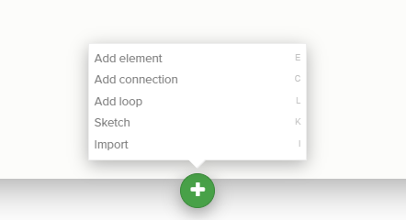

Figure 41: Screen clip of how to import within the KUMU interface.

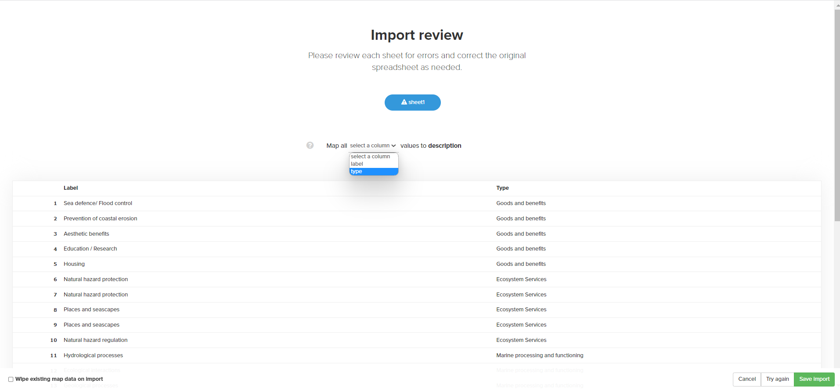

Figure 42: Screenshot of the KUMU interface and where to click to iimport the labels and types csv file.

1. Copy the all code from the file named ‘Kumu_Code_Style’ and paste in to the advanced editor in Kumu (Figure 43 &44).

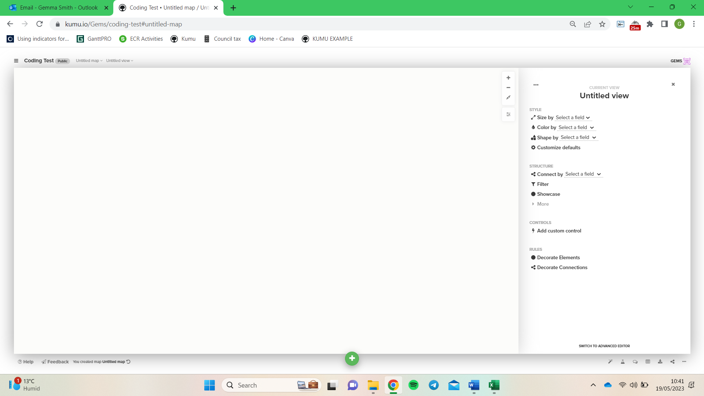

Figure 43: Screenshot of the KUMU interface of where to click to access the advanced editor.

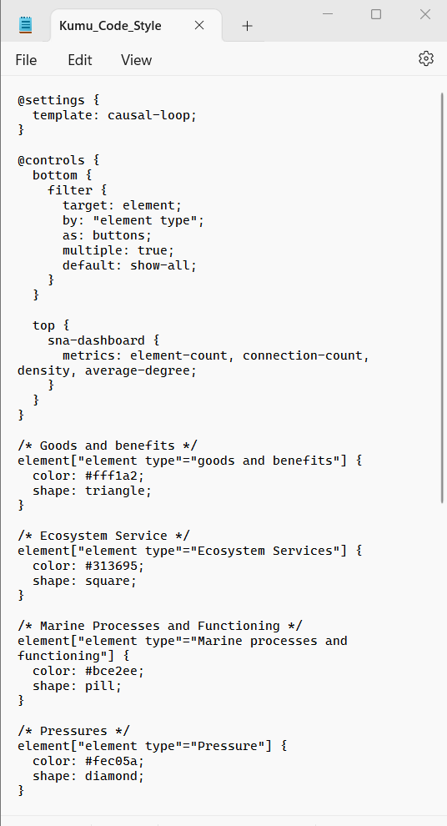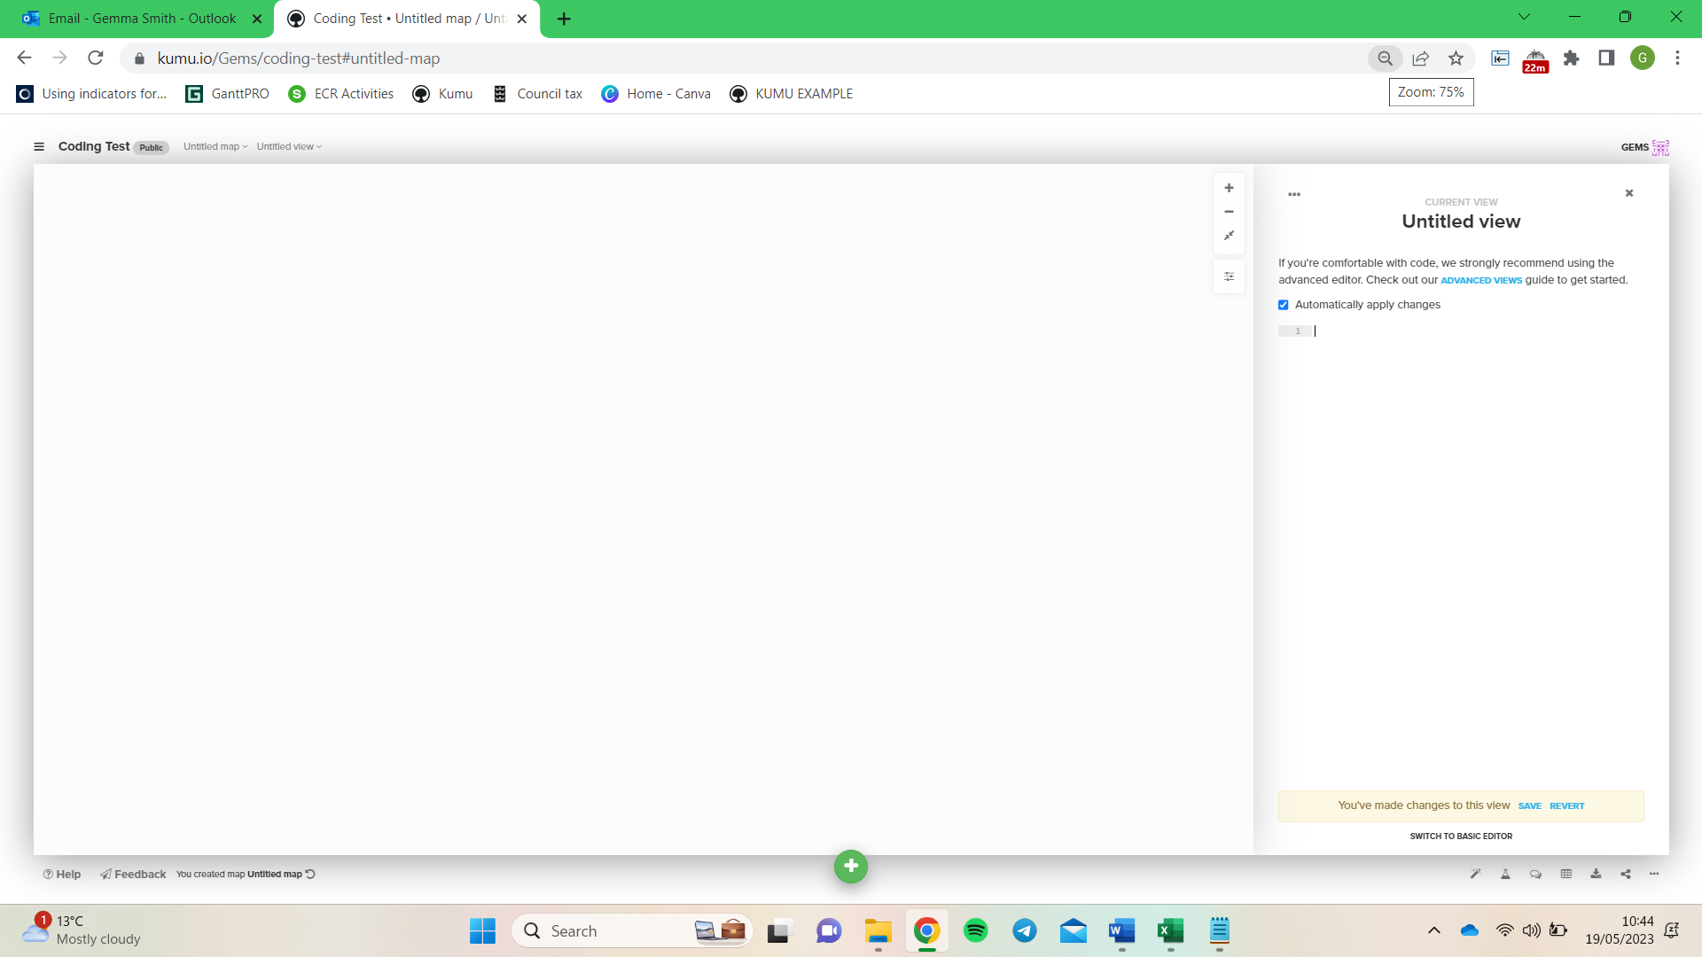

Figure 44: Where to copy and paste the 'Kumu_Code_Style' within the KUMU interface.

#### Importing Adjacency Matrix and Decorating Connections

When completing the adjacency matrices in earlier exercises, this information auto-populated a sheet in the workbook formatted to be compatible with the Kumu software. To retrieve these sheets and make them able to be uploaded into Kumu, please use the links on the home page in row 16 to download each sheet as a .csv file. Exercises 2 – 7 included this step, although this is a stage to make sure all are downloaded, saved and named appropriately and imported to Kumu ready for the analysis.

**REMEMBER:**

A PIMS Consideration when downloading multiple .csv files, it is recommended to save them in a file altogether and name them appropriately so you can find the files easily when importing to Kumu.

1. Download the six adjacency matrices as .csv files using the links in row 16 of the Home sheet to a locatable folder on your device (Figure 45).

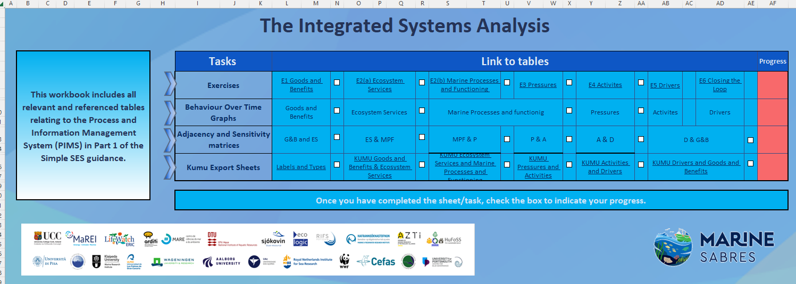

Figure 45: Location within the ISA Excel document to locate the KUMU formatted information.

1. Upload each of the csv files to Kumu using the import button (make sure you do not wipe previous data on import).
2. Now that you have customised the decoration of elements and connections, you should save this ‘view’ by giving it a name (see tabs at the top left-hand side) so that you will be able to see other Impact based CLDs that you create in this project through this view, that is with this decoration.

#### Reflecting on BOT alongside CLD

At this point, you may wish to spend some time reflecting on the CLD that you have created, how it captures Dynamic Complexity and Behaviour Over Time (BOT) ([https://thesystemsthinker.com/behaviour-over-time-diagrams-seeing-dynamic-interrelationships/](https://thesystemsthinker.com/behavior-over-time-diagrams-seeing-dynamic-interrelationships/)).

BOT graphs (also called ‘reference modes’) show the pattern of behaviour of elements over an extended period of time e.g. a reinforcing loop may show a BOT of a virtuous or vicious nature as the growth or decline of something may have positive or negative consequences depending on the context. In BOT graphs, the horizontal axis represents time and the vertical axis represents the performance measure of interest. The important parts of BOTs are the overall directions and variations, not the numerical value of the element. Therefore, BOTs usually give rough indications not the exact numerical value of the element. The behaviour of several elements can be shown in the same BOT graph.

Whilst the DAPSI(W)R(M) is useful for issue structuring, it tends to lead us to focus on identifying data gaps, but not really doing anything about them or knowing whether they are important, so understanding can be constrained by the data that is readily available. BOT graphs can help break the data availability dilemma by building causal theories before we look to gather the necessary data. The BOTs can be used to connect past observed behaviour with future behaviour in a way that offers insight into underlying causal structures and through our the development of our understanding of potential system behaviours guide our search for data to prove or disprove such theory building.

Behaviour over time graphs can be used to identify which types of system processes are occurring. For example, a rapidly increasing or decreasing behaviour over time graph indicates that reinforcing loops are influencing the system (see Figures A and B in Figure 46). In contrast, an oscillating behaviour over time graph would indicate that balancing feedback mechanisms are occurring in the system (see Figure C Figure 46).

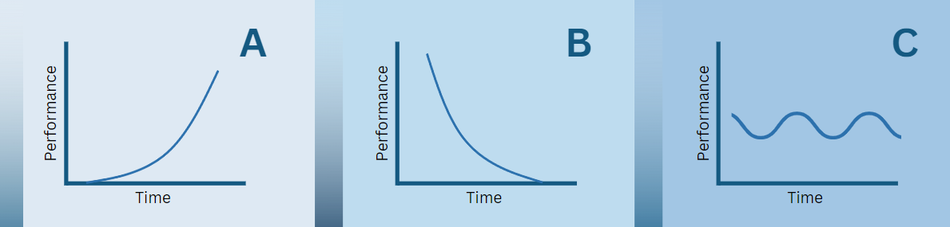

Figure 46: Behaviour over time Graphs – A and B represent reinforcing feedback loops, and C represents a balancing feedback loop, redrawn from Mclean, et al. (2019).

In summary, the behaviour of elements key to the issue of concern are plotted in a BOT and a theory of causal behaviour is articulated. Data are then sourced to either prove or disprove the theory. An iterative process between theory-building and data analysis will create a better understanding of the situation studied.

### Exercise 8: Moving from Causal Logic Chains to Causal Loops

The DAPSI(W)R(M) model as mapped on to risk assessment and management (Cormier et al. 2019) may be used to identify causal logic chains (e.g. using Bow-tie analysis) but this implies that the marine environment can be managed on the basis of linear cause and effect which may neglect important feedback interactions between elements unless sequential Bow-ties are created. Alternatively, Causal Loop Diagrams (CLDs) help us understand how the parts of a system interact to give rise to emergent behaviours and properties, particularly how feedback can cause the behaviour of a system to be complex and difficult to understand and manage. Therefore, while DAPSI(W)R(M) can conceptualise many of the key elements and connections relating to our impact of concern, the analysis needs to be extended to focus on where there are feedback relationships that have not been captured so far and to allow closing some of the critical feedback loops.

As such, in undertaking the analysis, we first need to understand more about types of feedback loop and labelling conventions. There are sign and letter types of loop polarity indicator in CLDs:

A ‘positive feedback’ or ‘reinforcing’ loop - this type of loop is often marked with the letter ‘R’ or ‘R’ is included in the naming of the loop. This type of feedback loop can be associated with growth or decline.

A ‘negative feedback’ or ‘balancing’ loop - this type of loop is often marked with the letter ‘B’ or ‘B’ is included in the naming of the loop. This type of feedback loop can be associated a steady state or goal-oriented behaviour.

Loop polarity is often established by assessing whether there is an odd or even number of negative links in a loop – if there is an even number of negative links in a loop then the loop is likely to be a positive feedback loop; conversely, an odd number of negative link in a loop is likely to be a balancing loop. However, this short-cut way of working out the overall effect of a loop can lead to mislabelling so it is important to think about the logic of each loop that you identify as you label it. In addition, hash (#) marks on the connector arrows between elements denote delays between cause and effect.

When drawing small CLDs, feedback loops can be relatively easy to identify (video available at [https://docs.Kumu.io/guides/what-are-loops](https://docs.kumu.io/guides/what-are-loops)) but when CLDs get larger then there can be feedback loops that are not so easy to identify that drive system behaviour. In order to detect such loops, Kumu has a useful automatic loop detection function:

1. Click on the green plus icon at the bottom of your CLD, and choose "Add loop" (Figure 47).
2. Click "detect loops automatically".
3. A menu will pop up on the left side of your CLD with the detected loops.

 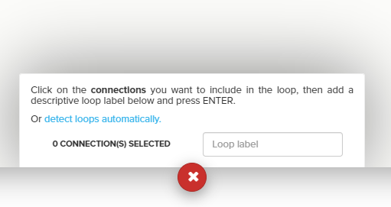

Figure 47: Screenclip of where to click in the KUMU interface to conduct the automatic loop analysis.

Loops are ranked from shortest (least number of elements) to longest (most elements) and placing the cursor over any loop name will indicate it both on the CLD and show which elements/connections are a part of it. It is important to name and save identified loops by Clicking on any loop number to give it a name and press enter on your keyboard (if you do not press enter then the name of the loop will not be registered). In order to edit a loop, click on the loop label to open its profile in the left side panel. In the bottom right corner of the profile, click the pencil icon to select and de-select connections that are a part of the loop (Figure 48).

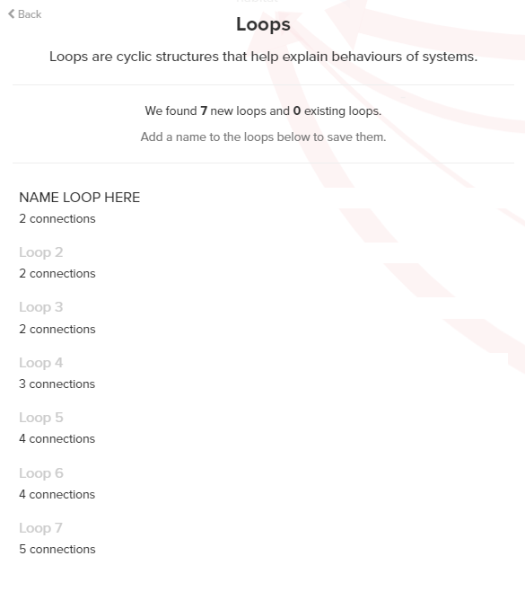

Figure 48: Screenclip of where to click and type within the KUMU interface to name Loops in the diagram, which also saves loops on the map.

Adding a name to a loop will add that label to your map in the centre of the loop. If the loop name is not immediately visible, then beware that it could be hidden behind an element. Remember, unnamed loops are not saved in your dataset.

You can generate a spreadsheet of all of the loops in your CLD using the Table function (this function also allows you to view and edit the underlying data in your map as a spreadsheet) see: [https://docs.Kumu.io/guides/table](https://docs.kumu.io/guides/table). You can access Table by clicking the spreadsheet icon in the lower right corner of your map. It is recommended that you keep an Excel file of all of the loops in each of your CLDs (you may wish to create different sheets for each CLD). You may want to identify those loops that you believe are significant by, for example, emboldening their labelling.

Below you can find summary advice on how to phrase the CLD and avoid difficulties (Haraldsson and Sverdrup, 2021, modified from Richardson and Pugh, 1981).

*Variables should be self-explanatory:*

The variables in the CLD should be nouns or noun phrases, not verbs, i.e. variables which represent measurable quantities that can fluctuate (e.g., litres of water, population and money). These measurable quantities help to give the main storyline(s) in the diagram.

*The action is in the arrows:*

The arrows tell the direction of the action in the story; for example, if spending increases and money decreases as a result, use an arrow (polarity) rather than a word to convey the decrease.

*Clarify the actions:*

Make it clear what a variable does when you send an action through (i.e., when an arrow is used); for example, write ‘tolerance for poor water quality’ rather than ‘attitude towards water quality’ as ‘tolerance’ is a more specific descriptor than ‘attitude’ (i.e., ‘tolerance’ and therefore ‘intolerance’ fall under the category ‘attitude’). In addition, rather than using causal links to mean ‘and then’, simply interpret the link as an increase or a decrease.

*Always use units:*

If no units are attached to the variables, they will need to be created. While some social or welfare variables may be difficult to quantify, using a scale (e.g., 0-100 or a Likert-like scale where numbers represent a range of responses from, for example, definitely not, not likely, likely, very likely, and definitely yes) is an acceptable way to define units. This is useable when dealing with dimensionless variables such as happiness, anger or stress.

*Use positive wording:*

Use positive expressions when labelling variables as experience suggests that users of the diagrams find positive expressions easier to interpret than negative expressions. When reading polarities in a loop, positive expression creates a better flow for the reader, whereas negative expression tends to create a double negative in the interpretation.

*Avoid double explanations of variables:*

If there is more than one event in a variable when an action runs through it, make these events new variables and explain what they do. For example, a variable named "Fishing Activities." This could include two distinct events: "Commercial Fishing" and "Recreational Fishing." Each of these events could have different influences on the marine ecosystem, and thus, could create complexity in our model. To avoid double explanations of the "Fishing Activities" variable, we should create these events as new variables, which can help clarify the overall system dynamics. Instead of having a single "Fishing Activities" variable affecting, say, "Fish Population," we would now have two distinct variables: "Commercial Fishing" and "Recreational Fishing." Each of these new variables would then connect separately to "Fish Population," allowing us to better understand and articulate their specific impacts and interrelationships within the marine ecosystem. By separating these activities into their own variables, we can more accurately represent their unique effects on the marine environment, such as the potentially more significant impact of commercial fishing due to its scale and intensity compared to recreational fishing.

**REMEMBER:**

*A loop has to have feedback, if not, it is not a loop -* Remember, only classify a feedback loop as reinforcing or balancing if it is circular.

### Exercise 9: Exporting your CLD and Creating/Adding to your Issue-based CLD

*Exporting:*

In order to create a back-up of your CLD and also for creating/adding to the Issue-based CLD, it is necessary to export each of your Impact-based CLDs after you have created them. This is achieved by: Open your Impact-based CLD; Click on the ‘Export’ button in the bottom right hand corner (Figure 49); Select ‘Export JSON’ and the file will automatically save to your downloads folder. It is recommended that you rename the file and save it to your project folder as this is your back-up file. For the purposes of creating/adding to the Issue-based CLD, select ‘Export XLSX’ and the file will automatically save to your downloads folder. It is recommended that you rename the file and save it to your project folder.

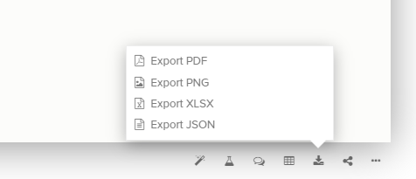

Figure 49: Screenclip of where to click within the KUMU interface to export the data to a JSON file.

*Creating an overall Issue-based CLD that is a composite of all of the separate Impact-based CLDs:*

* To create an Impact-based CLD, it is recommended that you create a new project in Kumu.
* To add your first Issue-based CLD to it, click on the green button in the bottom centre of your screen. Select ‘import’ and choose the .JSON file that you have just downloaded as this should carry the custom decorations of elements and links with it but you will have to label this view in your new project.
* Each time that you create a new Impact-based CLD, it is recommended that, after you have done a loop analysis, you export the file as an .xlsx and then import it to your Issue-based CLD (if you use an .xlsx file then it will add it to your Issue-based CLD but a .JSON file will not do this). It is possible that the process will create new causal loops that are not present at the individual Impact-based CLD level so it is important that each time you do an automatic loop analysis, name them and keep a note of any additional loops that are created.
* All of the loops that are present in the Impact-based CLDs will also be present in the Issue-based CLD and there may be significant additional loops that are also created. You may wish to do a loop analysis at the Issue level and cross check the loops identified in the Impact-based CLDs.

**REMEMBER:**

Some maps are simply too large for Kumu to automatically detect loops, as the number of loops on a highly inter-connected system map can quickly run into the thousands. If you notice that loop detection is not giving you any results, you can try one of two things: (1) try simplifying your map by deleting unnecessary elements and/or connections (see following section on clarifying), and (2) filter out one part of your map and run loop detection again. Make sure to save your loops before you filter another part of the map!

### Exercise 10: Clarifying

Once you have developed Impact-based CLDs for all your priorities and imported all of these into one composite Issue-based CLD, it is likely that the Issue-based CLD will be of some considerable complexity with many elements and connections. Whilst the model may be seen to represent the complexity of the issue, it is likely to be somewhat cumbersome and there is a need to focus on creating a simpler, fundamental version of the working model.

During model building, the complexity together with the information value is increasing but, given our limited cognitive capacity to comprehend complexity, we have to bear in mind that we can reach an optimal point where more information actually brings less value but simplifying the module can add value and understanding - grasping the whole picture is more important, at this point, than the detail.

The simplification method is based on two activities: *endogenization* and *encapsulation* (Bureš, 2017). Prior to discussing these processes, it is first necessary to consider the elements in a CLD which are either endogenous, both influencing and influenced by other variables within the CLD, or exogenous, influencing but not being influenced by other variables. Because of the process that we have followed in constructing our CLDs, you are likely not to have any exogenous elements.

Endogenisation:

This process deals with elements in your CLD that only have an effect on other elements but are not influenced by anything within the system, these are known as exogenous elements. An example in a marine context might be the amount of sunlight that reaches the ocean surface. This has a direct impact on the photosynthesis rate of phytoplankton but isn't directly affected by other elements within the marine ecosystem.

In endogenisation, we identify and list all these exogenous elements. By doing so, we make a record of their influence within the system. The purpose of listing these elements is so that we remember their impacts even when they are removed in the simplification process. After identifying and listing, we can remove these exogenous elements from the CLD. The reason we do this is to make the system easier to understand and ensure that all remaining elements in the CLD have influences that are contained within the system itself.

#### Encapsulation:

This process is focused on variables that only have one input and one output, known as Single Input Single Output (SISO) variables. In a marine context, an example might be the transformation of sunlight into photosynthetic energy by phytoplankton. This element takes one input (sunlight) and produces one output (photosynthetic energy).

To encapsulate, first, we identify and mark all SISO variables in the CLD. We do this so we can keep track of these transformation elements that help understand how the system dynamics move from one point to another. Next, we 'bridge' or bypass these SISO variables, effectively simplifying the CLD by removing these transformation steps and connecting the original input directly to the output. While doing this, we need to consider the new link's polarity, which can be determined based on the number of links with negative polarities. For example, if sunlight (input) was linked to phytoplankton growth (output) through the SISO variable 'photosynthetic energy', in encapsulation we would remove 'photosynthetic energy' and directly link sunlight to phytoplankton growth.

*Remember, the goal of both endogenisation and encapsulation is to simplify the CLD, making it easier to understand the main connections and influences within the system, rather than getting lost in the details.*

### Exercise 11: Metrics, Identifying Root Causes and Leverage Points

Through their creation, CLDs serve to make clear your metal models (mind-maps), or those derived by the stakeholders during WP2s. The CLD developed can be analysed and used in several ways (e.g. how to interpret a CLD - <https://www.linkedin.com/advice/0/how-do-you-use-causal-loop-diagrams-identify>) (see also, Haraldsson, 2021). The analysis of a CLD can identify leverage points for change (see Figure 50 for an analysis-based problem-solving map). By focussing on those elements that significantly influence system behaviour (multi-input and multi-output variables), we are able better able to capture a meaningful explanation of system behaviour and identify how it can be influenced. These are the areas in the system where a minor alteration can have a significant effect on the system behaviour. To locate the leverage points, you should investigate the feedback loops that are causing the problem or hindering the defined goal and consider how to weaken or break them.

Additionally, you should look for the feedback loops that are supporting the goal or resolving the issue and contemplate how to strengthen or create them. Furthermore, you should search for the delays or impediments that are creating inertia or instability and contemplate how to reduce or increase them. Additionally, you should search for the parameters that are influencing the feedback loops and consider how to adjust or modify them. Lastly, you should aim to create the mental models that are forming the causal links and the feedback loops and contemplate how to challenge or change them (see also the stakeholder-created mind-maps in Marine SABRES WP2).

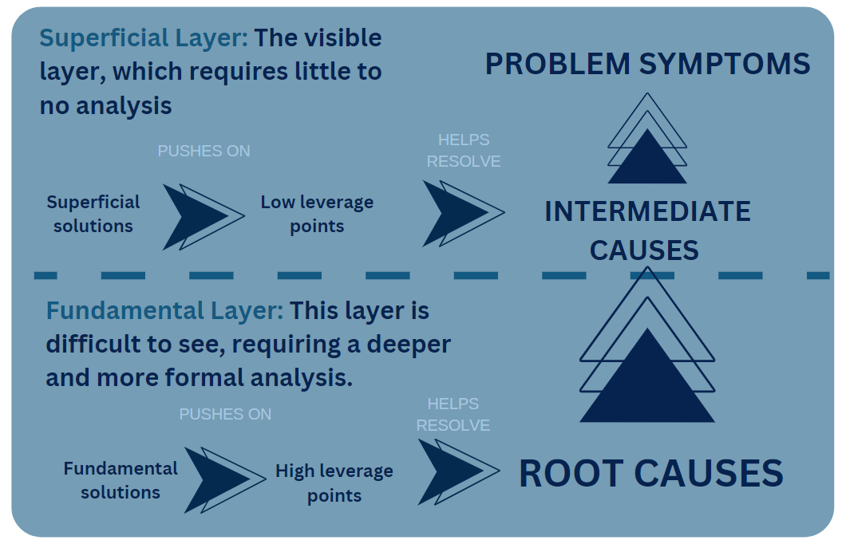

Figure 50:An analysis-based problem-solving map redrawn from Lane (2008).

Kumu offers a range of metrics and the following may be useful in analysing our CLDs (Table 6). These metrics were found in the Kumu documents, which can be accessed [here](https://docs.kumu.io/guides/metrics).

Table 6: Table extracted from the Kumu help documents which detail various metrics of analysis for CLDs.

|  |  |
| --- | --- |
| **Metric** | **Description** |
| Degree | This counts the number of connections linking an element. |
| Closeness centrality | This measures the distance (in terms of the number of connections) each element is from all other elements. Elements with high outward closeness can spread information to the rest of the network most easily and usually have high visibility into what is happening across the network. |
| Betweenness centrality | This measures how many times an element lies on the shortest path between two other elements. In general, elements with high betweenness have more control over the flow of information and act as key bridges within the network. They can also be potential single points of failure. |
| Size | Size measures the number of neighbours an element has (plus the element itself). It is similar to degree but counts the number of elements instead of connections. |
| Indegree | Indegree measures the number of incoming connections for an element. In general, elements with high indegree are highly influenced by other elements. |
| Outdegree | Outdegree measures the number of outgoing connections for an element. In general, elements with high outdegree can reach a high number of elements and offer a potential point of leverage as small changes in this element may cascade throughout the system. |
| Eigenvector | Eigenvector centrality measures how well connected an element is to other well-connected elements. In general, elements with high eigenvector centrality are the leaders of the network, though they may not have the strongest local influence. |
| Reach (two-step out) | Reach measures the portion of the network within two steps of an element. In general, elements with high reach can spread information through the network through close friend-of-a-friend contacts. |
| Reach efficiency | Reach efficiency normalizes reach by dividing it by size (number of neighbours). In general, elements with high reach efficiency are less connected but gain more exposure through each direct relationship. |
| MICMAC | MICMAC is a system analysis that explores element exposure (how much a given element is affected by other elements) and influence (how much a given element affects other elements). When plotted on an XY axis, these scores help you identify potential leverage points within the overall system. |

Certain fields also support weighting so you can include fields like strength and frequency in the calculations. Betweenness, closeness and degree use connection fields for weighting while size and reach use element fields for weighting.

For the metrics that allow weighting, you'll see an Advanced Options link once you select the metric. You can choose any numerical field for the weighting, but make sure you have values saved for the elements or connections based on which is used for the weighting. If you do not see the field you want to use listed, make sure the type for that field is set to numeric.

By default, all metrics are saved to a field with the name of the metric (betweenness calculations are saved to the "betweenness" field). Each time you run the metric the previous values are overwritten. If you wish to keep the previous values, rename the field (maybe it is "2014 betweeness" or "betweeness before") so that future saves do not overwrite the values.

Portraying which elements are the most well-connected can be achieved by combining metrics and sizing. First, run metrics to let Kumu calculate the number of connections of each element:

* Click on the "Metrics" icon in the bottom right corner of the map
* Select “Social Network Analysis" to open the Metrics menu
* Choose the “degree” metric from the dropdown list
* Click the large button "Discover the connectors/hubs" to see the results
* Kumu will automatically create a field called “degree” and save the values

**REMEMBER:**

* To rerun metrics (for example, if you added new elements and connections), just follow the same steps again.
* Metrics will not be calculated for elements that are filtered out of the map.
* To save multiple versions of the same metric, follow [this guide](https://docs.kumu.io/guides/metrics#saving-multiple-versions-of-a-single-metric)
* You can run any of the metrics mentioned [in this guide](https://docs.kumu.io/guides/metrics#sna-metrics) and then size based on them.
* Once the metrics are calculated, you can size your elements by going into Settings on the right and changing the "Size By" dropdown of the Basic Editor to the field of the metric you calculated (e.g. "degree"). More information on sizing can be found in [this guide](https://docs.kumu.io/guides/decorate/data-driven-decorations#size-by).

*In summary:*

* Walk through the major feedback loops, identify what type they are, and reduce them to the process that they are capturing
* Estimate the delays to estimate the timescale of each feedback loop
* Identify which elements and loops are dominant
* Consider if there are any aspects that are missing
* Consider the potential unintended consequences or side effects of intervening in the system
* Examining the above questions can help to provide a more comprehensive analysis of a CLD.

Exercise 12: Presenting and validating a CLD and analysis

Presenting the CLDs that you have developed to stakeholders and gaining their comments and insights is an important part of validating your model. Validation is key to minimize any unconscious bias or ‘groupthink’ that may have been introduced by the group during development or misinterpretation of data.

When presenting your CLD to stakeholders, it is important to align the complexity of a CLD to the visual abilities of your audience (Barbrook-Johnson and Penn, 2022). If an audience will be discouraged or confused by large CLDs, or be confused by multiple interacting feedback loops, consider how the map can overcome this problem. The aim should not be to just produce a very simple CLD, although you may end up doing this, but to also think carefully about how you might frame and introduce it in ways which allow you to keep as much complexity as possible (e.g. introduce the impact CLDs first before presenting the issue-based composite CLD).

Kumu offers a number of features that may assist with this. [Views](https://github.com/kumu/docs/blob/main/guides/views.html) offer many powerful features—[decorations](https://github.com/kumu/docs/blob/main/guides/decorate.html) for sizing and colouring your data, [filters](https://github.com/kumu/docs/blob/main/guides/filter.html) for showing/hiding different items, [controls](https://github.com/kumu/docs/blob/main/guides/controls.html) for adding rich interactivity to your maps, etc. Different views [can also be layered on top of one another via the @import syntax](https://github.com/kumu/docs/blob/main/guides/imported-views.html). For most maps, you can present a view that highlights your data in the best way possible, but more complex data demand a more complex visual approach, e.g. using different colour-coding and sizing rules, levels of focus, cluster connections. In essence, to get the most out of a more complex dataset, you will need to create several different visual variations (see the video at: [https://docs.Kumu.io/guides/partial-views](https://docs.kumu.io/guides/partial-views)).

The focus feature ([https://docs.Kumu.io/guides/focus](https://docs.kumu.io/guides/focus)) allows you to focus on one or more elements, connections, and loops, temporarily hiding the rest of the map. This is a very suitable tool for storytelling, allowing you to reduce the complexity of your system or network while you introduce the basic concepts behind your map. Focus is activated in one of two ways, by clicking and holding on any element, connection or loop or by selecting an element, connection or loop and then clicking the focus icon on the right side of your map. Once focus is activated, you can zoom in and out by degree using the and buttons. Click the focus icon again to bring the full map back into view.

Filter in the Basic Editor (<https://docs.Kumu.io/guides/filter>) Kumu code includes pre-defined sections. However, if you click the settings icon on the right side of the map, then click the icon to the right of **filter** to open up your filter settings you can amend these settings. If you are filtering by element or connection type, simply un-check the types you want to hide. To filter using other fields, use the "also include" and "but ignore" fields.

Click the rocket icon to the right of the input of each field to select what you want to hide or make visible. If you have hidden certain elements and connections using the type checkboxes, you can use the Also include tool to bring things back into view. However, you first have to un-check some of the boxes above, or this tool will have no effect. Use the But ignore tool to hide elements and connections from your map. Anything you add here will override the settings in the checkboxes above and the Also include tool.

Presentations in Kumu combine the best of PowerPoint, Prezi, and Kumu into one easy-to-use tool. Combine text, video, images and maps into a single, engaging presentation that anyone can access via URL ([https://docs.Kumu.io/guides/presentations](https://docs.kumu.io/guides/presentations)).

#### Stakeholder dialogue

Stakeholder dialogue is the most popular method to validate CLDs simply by asking stakeholders questions such as:

* Does this make sense?
* Are we missing anything important in this section of the diagram?
* Is there anything that you feel should be removed in the diagram?
* Does this part of the system exist to your knowledge?
* Are appropriate system variables represented? If not, what variables are missing or should be removed?
* Are appropriate in- and out-flows represented? If not, what flows are missing or should be removed?
* Is the polarity of in- and out-flows accurately represented? If not, what changes would you make?
* Are delays in the system represented appropriately according to our knowledge of BOT? If not, what delays are missing, should be removed or changed?

Once the logic and structure of the CLD has been validated, it is important to focus on the dynamics and outcomes of your proposed responses, and a theory of change or storytelling approach can be used ([https://blog.Kumu.io/how-systems-mapping-can-help-you-build-a-better-theory-of-change-4c85ae4301a8](https://blog.kumu.io/how-systems-mapping-can-help-you-build-a-better-theory-of-change-4c85ae4301a8); Loops and Storytelling - <https://www.youtube.com/watch?v=eZfIdWtFkRI>).

### Exercise 12: Including Response (as management Measures) interventions in the system

Responses (as management Measures) affect the marine system in focus through management and operational actions (analogous to the operational and management controls in wider management systems, see Cormier et al., 2019). For example: an intervention such as an education initiative is an action and may be designed to change consumer tastes and preferences and therefore their needs and wants; controls over certain fishing practices and gear restrictions will alter specific fishing activities. The CLD, based on the inclusion of particular indicators, and the BOT graphs capture the type and effect of past responses (measures) in the system (although, in practice, more recent responses may still be being implemented and/or their affects working through the system). It is necessary to identify new response(s) or changes in existing response(s) that are being considered as options to address the issue of interest, and identify which activity/ies in the system are affected by these interventions and how they are affected (i.e. a selected response may alter existing activity(ies) and/or create new activity(ies)).

Once you are satisfied that you have sufficiently developed, explored, validated and, where appropriate, simplified each Impact-based CLD and your composite Issue-based CLD, it is necessary to consider how to change the system behaviour to shift to a more desirable state. New response interventions being considered to address the focal issue/impact may involve taking action to change the current state of an element or introducing a new element in order to:

* Disrupt (positive/reinforcing loops) ‘vicious cycles’ and negative/balancing loops that might be suppressing desirable change.
* Encourage ‘virtuous cycles’ and or interrupting negative/balancing loops negative/balancing loops to support desirable change.

In addition, it is desirable to identify/seek to identify and influence leverage points, those elements that significantly influence system behaviour (multi-output elements). For each potential response being considered, it is important to trace through the effects of this through the system in focus articulating both storylines associated with dominant loops, the behaviour over time of key elements and the theory of change that will lead to an improved system state; it is necessary to keep a record of these.

In this final stage, response measures are chosen, and an action plan to implement can be arranged. The PIMS project stages can guide the closure of the project, and decisions relating to objective and goal evaluation can be made. The resulting response measures can include any relevant monitoring or future work, and the adaptive cycle will have this information for future iterations.

## References:

Ackermann F and Eden C (2011) Strategic management of stakeholders: theory and practice Long. Range Plan., 44, pp. 179-196, <https://doi.org/10.1016/j.lrp.2010.08.001>

Barbrook-Johnson, P., Penn, A.S. (2022). Causal Loop Diagrams. In: Systems Mapping. Palgrave Macmillan, Cham. <https://doi.org/10.1007/978-3-031-01919-7_4>

Bell, Simon; Berg, Tessa and Morse, Stephen (2016). Rich Pictures: Sustainable Development and Stakeholders – The Benefits of Content Analysis. Sustainable Development, 24(2) pp. 136–148.

Borja Á., Elliott M., Carstensen J., Heiskanen A.-S., van de Bund W., 2010. Marine management–towards an integrated implementation of the European Marine Strategy Framework and the Water Framework Directives. Marine Pollution Bulletin,60, 2175-2186.

Bureš V. (2017) A Method for Simplification of Complex Group Causal Loop Diagrams Based on Endogenisation, Encapsulation and Order-Oriented Reduction. Systems. 5(3):46. <https://doi.org/10.3390/systems5030046>

Cormier, R., Elliott, M. & Borja, Á. (2022) Managing Marine Resources Sustainably – The ‘Management Response-Footprint Pyramid’ Covering Policy, Plans and Technical Measures. *Frontiers in Marine Science*. <https://www.frontiersin.org/articles/10.3389/fmars.2022.869992>

Cormier, R., Elliott, M., Rice, J., (2019). Putting on a Bow-tie to sort out who does what and why in the complex arena of marine policy and management. Science of the Total Environment, 648: 293-305. <https://doi.org/10.1016/j.scitotenv.2018.08.168>.

CSWD,2020. Commission Staff Working Document: Background document for the Marine Strategy Framework Directive on the determination of good environmental status and its links to assessments and the setting of environmental targets. Accompanying the Report from the Commission to the European Parliament and the Council on the implementation of the Marine Strategy Framework Directive (Directive 2008/56/EC). European Commission SWD(2020) 62 final.

DOI: <https://doi.org/10.1002/sd.1614>

Elliott M., Boyes S.J.,Cormier R., 2022a. The operationalisation, governance and achievement of Good Environmental Status for UK marine areas. Unpublished Discussion Paper for Natural England, International Estuarine & Coastal Specialists (IECS) Ltd, Leven, HU17 5LQ, UK; pp112, <https://www.iecs.ltd>

Elliott M. D. Burdon, J.P. Atkins, A. Borja, R. Cormier, V.N. de Jonge, R.K. Turner. (2017)“And DPSIR begat DAPSI(W)R(M)!” - A unifying framework for marine environmental management, Marine Pollution Bulletin, <http://dx.doi.org/10.1016/j.marpolbul.2017.03.049>

Elliott, M. (2023). Marine Ecosystem Services and Integrated Management: “There’s a crack, a crack in everything, that’s how the light gets in”! Marine Pollution Bulletin, 193: https://doi.org/10.1016/j.marpolbul.2023.115177

Elliott, M., Borja, Á. & Cormier, R. (2020) Managing marine resources sustainably: A proposed Integrated Systems Analysis approach. Ocean & Coastal Management, 197. <https://doi.org/10.1016/j.ocecoaman.2020.105315>

Elliott, M., Borja, A., Cormier, R. (2020). Activity-footprints, pressures-footprints and effects-footprints – walking the pathway to determining and managing human impacts in the sea. Marine Pollution Bulletin, 155: 111201; https://doi.org/10.1016/j.marpolbul.2020.111201.

Elliott, M., Boyes, S.J., Barnard, S., Borja, Á. (2018). Using best expert judgement to harmonise marine environmental status assessment and maritime spatial planning. Marine Pollution Bulletin, 133: 367-377; https://doi.org/10.1016/j.marpolbul.2018.05.029.

Elliott, M., Snoeijs-Leijonmalm, P. and Barnard, S., (2017). 'The dissemination diamond'and paradoxes of science-to-science and science-to-policy communication: Lessons from large marine research programmes. *Marine Pollution Bulletin*, *125*(1-2), pp.1-3. <https://doi.org/10.1016/j.marpolbul.2017.08.022>

European Commission, 2000. Directive 2000/60/EC of the European Parliament and of the Council of 23 October 2000 establishing a framework for community action in the field of water policy. Official Journal of the European Union, L327: 1-72.

European Commission, 2008. Directive 2008/56/EC of the European Parliament and of the Council establishing a framework for community action in the field of marine environmental policy (Marine Strategy Framework Directive). Official Journal of the European Union, L164: 19-40.

Folke, C., Hahn, T., Olsson, P. & Norberg, J. (2005) Adaptive Governance Of Social-Ecological Systems. *Annual Review of Environment and Resources*, 30(1), 441-473.10.1146/annurev.energy.30.050504.144511. <https://www.annualreviews.org/doi/abs/10.1146/annurev.energy.30.050504.144511>

Forrester, J.W. 1961. Industrial Dynamics. Cambridge: MIT Press.

Haines-Young R., PotschinM.B.,2018. Common International Classification of Ecosystem Services (CICES) V5.1 and Guidance on the Application of the Revised Structure. Available from www.cices.eu 53 pp.

Haraldsson, H.V., 2004. Introduction to system thinking and causal loop diagrams (pp. 3-4). Lund, Sweden: Department of chemical engineering, Lund University.

Haraldsson, Hördur & Bonin, Daniel. (2021). Using systems approach to integrate Causal Loop Diagrams modelling in the foresight project Scenarios for a Sustainable Europe 2050. <https://doi.org/10.13140/RG.2.2.20575.18080>

IPCC, 2022: Climate Change 2022: Impacts, Adaptation, and Vulnerability. Contribution of Working Group II to the Sixth Assessment Report of the Intergovernmental Panel on Climate Change [H.-O. Pörtner, D.C. Roberts, M. Tignor, E.S. Poloczanska, K. Mintenbeck, A. Alegría, M. Craig, S. Langsdorf, S. Löschke, V. Möller, A. Okem, B. Rama (eds.)]. Cambridge University Press. Cambridge University Press, Cambridge, UK and New York, NY, USA, 3056 pp., doi:10.1017/9781009325844.

Lane, D.C. (2008), The emergence and use of diagramming in system dynamics: a critical account. Syst. Res., 25: 3-23. <https://doi.org/10.1002/sres.826>

Mclean, Scott & Read, Gemma & Hulme, Adam & Dodd, Karl & Gorman, Adam & Solomon, Colin & Salmon, Paul. (2019). Beyond the Tip of the Iceberg: Using Systems Archetypes to Understand Common and Recurring Issues in Sports Coaching. Frontiers in Sports and Active Living. 1. 49. <https://doi.org/10.3389/fspor.2019.00049>

Newton A and Elliott M (2016) A Typology of Stakeholders and Guidelines for Engagement in Transdisciplinary, Participatory Processes. Front. Mar. Sci. 3:230. <https://doi.org/10.3389/fmars.2016.00230>

Odum, EP, 1971. Fundamentals of Ecology. Saunders, Philadelphia, 3rd Ed

Ostrom, E. & Cox, M. (2010) Moving beyond panaceas: a multi-tiered diagnostic approach for social-ecological analysis. Environmental Conservation, 37(4), <https://doi.org/10.1017/S0376892910000834>

Ostrom, E. (2007) A diagnostic approach for going beyond panaceas. Proceedings of the National Academy of sciences, 104(39), 15181-15187 <https://doi.org/10.1073/pnas.0702288104>

Pouloudi, N; Currie, W; and Whitley, E A. (2016) "Entangled Stakeholder Roles and Perceptions in Health Information Systems: A Longitudinal Study of the U.K. NHS N3 Network," Journal of the Association for Information Systems, 17(2), <https://doi.org/10.17705/1jais.00421>

Richardson, P.G. and Pugh III, A., 1981. Introduction to system dynamics modeling. Productivity Press, Portland, 413 pp

Rosnay, J., 1979. The Macroscope: A new world scientific system. Harper & Row Publishers, New York, 247 pp.

Senge, P., 1990. The fifth discipline, The art and practice of the learning organisation. Century Business, New York.

Sterman, J.D., 2000. Business Dynamics, System Thinking and Modeling for a Complex World. Irwin McGraw-Hill, New York, 982 pp.

Videira, N., Lopes, R., Antunes, P., Santos, R., & Casanova, J. L. (2012). Mapping maritime sustainability issues with stakeholder groups. Systems Research and Behavioural Science, 29(6), 596-619. doi:10.1002/sres.2141

## Appendix 1: Supporting information

### A Note on CLDs and Scenarios

As analogous to the Shared Socio-Economic Pathways (SSP) from the Intergovernmental Panel on Climate Change (IPPC, 2022.) which are developed in Marine SABRES WP5, Haraldsson and Bonin (2021) illustrate the use of Causal Loop Diagrams (CLD) in the analysis of the Scenarios for a Sustainable Europe in 2050 (SSE 2050). The four scenario narratives (Ecotopia, A Pragmatic Path, Green Growth Paradigm, Utilitarian Technocracy for Good) from the SSE 2050 project were interpreted and contextualized to develop the CLDs in Kumu. In summary, scenarios and CLDs can be useful for informing responses by:

* Create a scenario CLD at the appropriate level (this may involve reinterpreting a global scenario CLD)
* Compare the scenario CLD with the already developed reference CLD

Exploring would need to happen for the system to transition from as its current state (the reference state) to the scenario CLD state (theory of change)? What actions could be taken to deal with any issues/impacts created through this process of change?

### Other useful links:

**Project management:** Extra information is available at: <https://www.projectsmart.co.uk/lifecycle-and-methodology/introduction-project-management.php>

**Kumu help:** [https://docs.Kumu.io/about-Kumu/where-can-i-get-help](https://docs.kumu.io/about-kumu/where-can-i-get-help)

**Adjacency Matrix help**: [https://docs.Kumu.io/frequently-asked-questions/how-do-i-restructure-my-adjacency-matrix](https://docs.kumu.io/frequently-asked-questions/how-do-i-restructure-my-adjacency-matrix)

**Connection types:** [https://docs.Kumu.io/guides/fields](https://docs.kumu.io/guides/fields)

**Systems Spaghetti:** [https://blog.Kumu.io/juggling-conflicting-purposes-for-system-maps-1f973d384aeb](https://blog.kumu.io/juggling-conflicting-purposes-for-system-maps-1f973d384aeb)

**Rich Pictures**: <https://www.open.edu/openlearn/science-maths-technology/engineering-technology/rich-pictures>

**Use of scenarios:** [https://blog.Kumu.io/exploring-the-future-four-ways-to-combine-future-scenarios-with-causal-loop-diagrams-78a6869af05f](https://blog.kumu.io/exploring-the-future-four-ways-to-combine-future-scenarios-with-causal-loop-diagrams-78a6869af05f)

**Theories of change and CLDs:** [https://blog.Kumu.io/how-systems-mapping-can-help-you-build-a-better-theory-of-change-4c85ae4301a8](https://blog.kumu.io/how-systems-mapping-can-help-you-build-a-better-theory-of-change-4c85ae4301a8)

**Use of Kumu for analysis:** <https://onlinelibrary.wiley.com/doi/abs/10.1002/sdr.1701>

### Further Reading:

* Rigorously interpreted quotation analysis for evaluating causal loop diagrams in late-stage conceptualization [Andrada Tomoaia-Cotisel](https://onlinelibrary.wiley.com/action/doSearch?ContribAuthorRaw=Tomoaia-Cotisel%2C+Andrada), [Samuel D. Allen](https://onlinelibrary.wiley.com/action/doSearch?ContribAuthorRaw=Allen%2C+Samuel+D), [Hyunjung Kim](https://onlinelibrary.wiley.com/action/doSearch?ContribAuthorRaw=Kim%2C+Hyunjung), [David Andersen](https://onlinelibrary.wiley.com/action/doSearch?ContribAuthorRaw=Andersen%2C+David), [Zaid Chalabi](https://onlinelibrary.wiley.com/action/doSearch?ContribAuthorRaw=Chalabi%2C+Zaid)
* Kenzie ES, Parks EL, Bigler ED, Wright DW, Lim MM, Chesnutt JC, Hawryluk GWJ, Gordon W and Wakeland W (2018) The Dynamics of Concussion: Mapping Pathophysiology, Persistence, and Recovery With Causal-Loop Diagramming. Front. Neurol. 9:203, <https://www.frontiersin.org/articles/10.3389/fneur.2018.00203/full>
* Causal Loop Diagrams in the book System Mapping : Barbrook-Johnson, P., Penn, A.S. (2022). Causal Loop Diagrams. In: Systems Mapping. Palgrave Macmillan, Cham. <https://doi.org/10.1007/978-3-031-01919-7_4>
* Get Your Model Out There: Advancing Methods for Developing and Using Causal-Loop Diagrams (PhD) Kenzie, E. S. (2021). *Get your model out there: Advancing methods for developing and using causal-loop diagrams*(Order No. 28318158). Available from Publicly Available Content Database. (2509246401). Retrieved from: <https://www.proquest.com/dissertations-theses/get-your-model-out-there-advancing-methods/docview/2509246401/se-2>
* Haraldsson, Hördur & Bonin, Daniel. (2021). Using systems approach to integrate Causal Loop Diagrams modelling in the foresight project Scenarios for a Sustainable Europe 2050. <https://www.naturvardsverket.se/4a4387/globalassets/media/publikationer-pdf/6900/978-91-620-6975-9.pdf>

### Frequently Asked Questions

**Q: How do I size elements based on number of connections?**

**A:** Want to know which element is the most well-connected? Here's where combining metrics and sizing comes in handy.

1. Click on the Metrics icon in the bottom right corner of the map
2. Select "Social Network Analysis"
3. Choose a metric from the dropdown list
4. Click the large button "Discover ..." (e.g. "Discover the connectors/hubs" for the "degree" metric)

To rerun metrics (for example, if you added new elements and connections), just follow the same steps again.

Metrics will not be calculated for elements that are filtered out of the map.

Video at [**https://docs.Kumu.io/guides/metrics**](https://docs.kumu.io/guides/metrics)

**[This section is to be expanded as the guidance is developed]**